Belhar Health Committee Support Group, Community Dialogue
Chestnut Clinic. April 2018
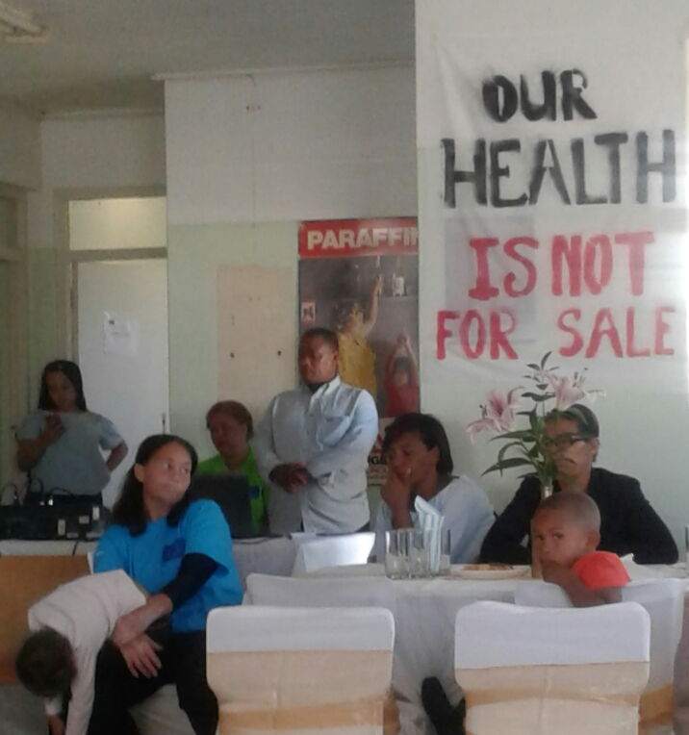
Figure 1: Wendy Leite (in front) Shawn Swartz (at back). Health trainees.
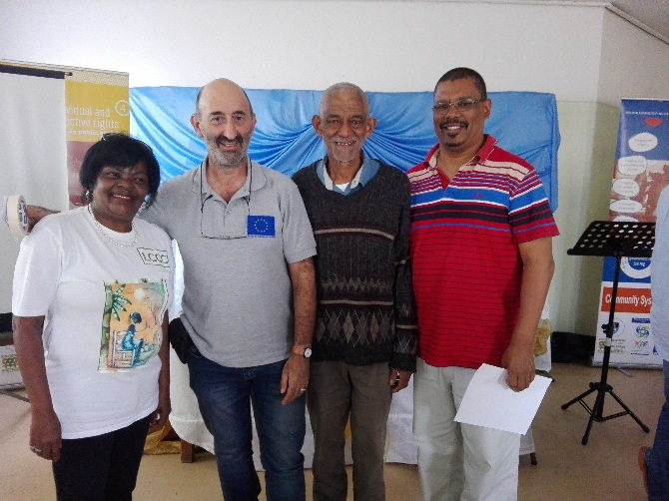
Figure 2: Food and Nutrition trainee, Colleen Jansen, Prof. London UCT, Mr Kelley BCHF, ANC Ward Councillor, Belhar.

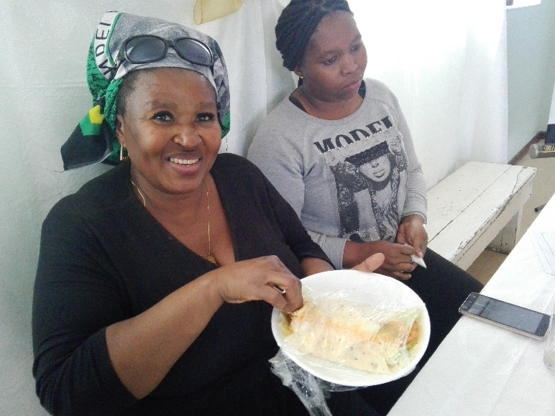
Figure 3: Thandi and Beauty, Tygerberg Health Committee (Unfortunately did not get their surnames)

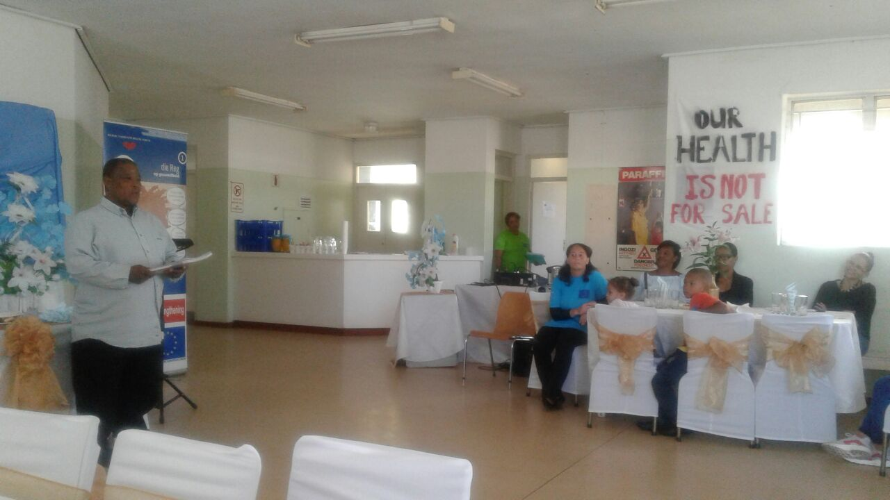
Figure 4: Shawn Swarrz, Health Committee Support team, group leader

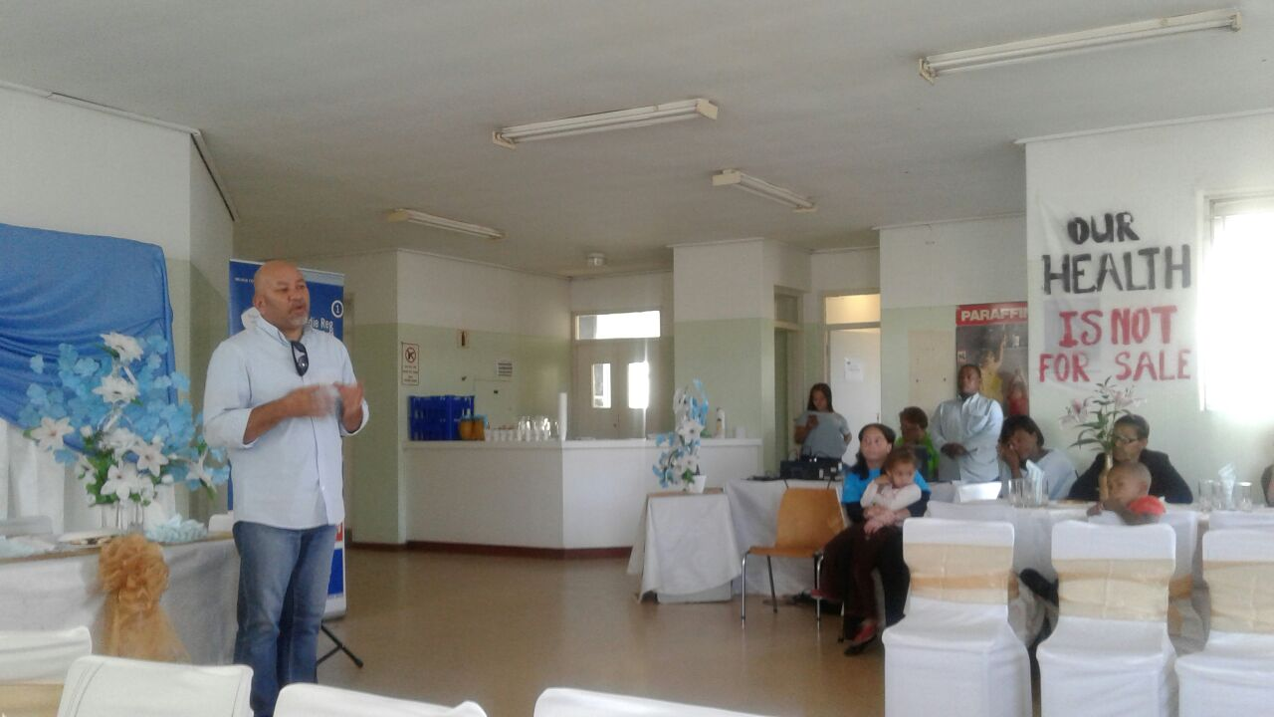
Figure 5: Gaffieldien Benjamin, Belhar Community Health Forum

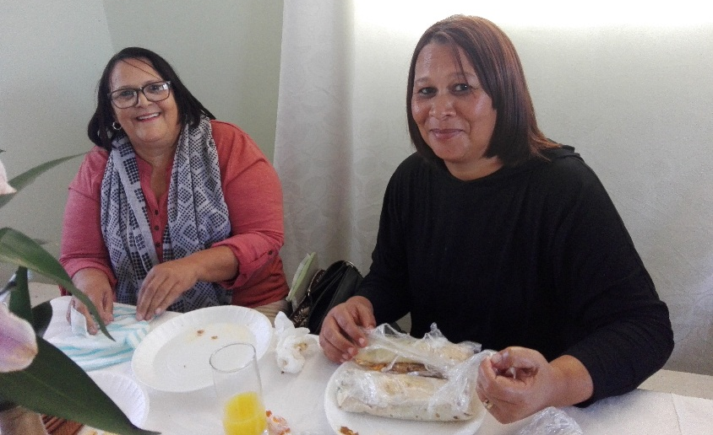
Figure 6: Mrs Carol Kelley (Kenneth’s wife) and daughter (can’t remember her name)

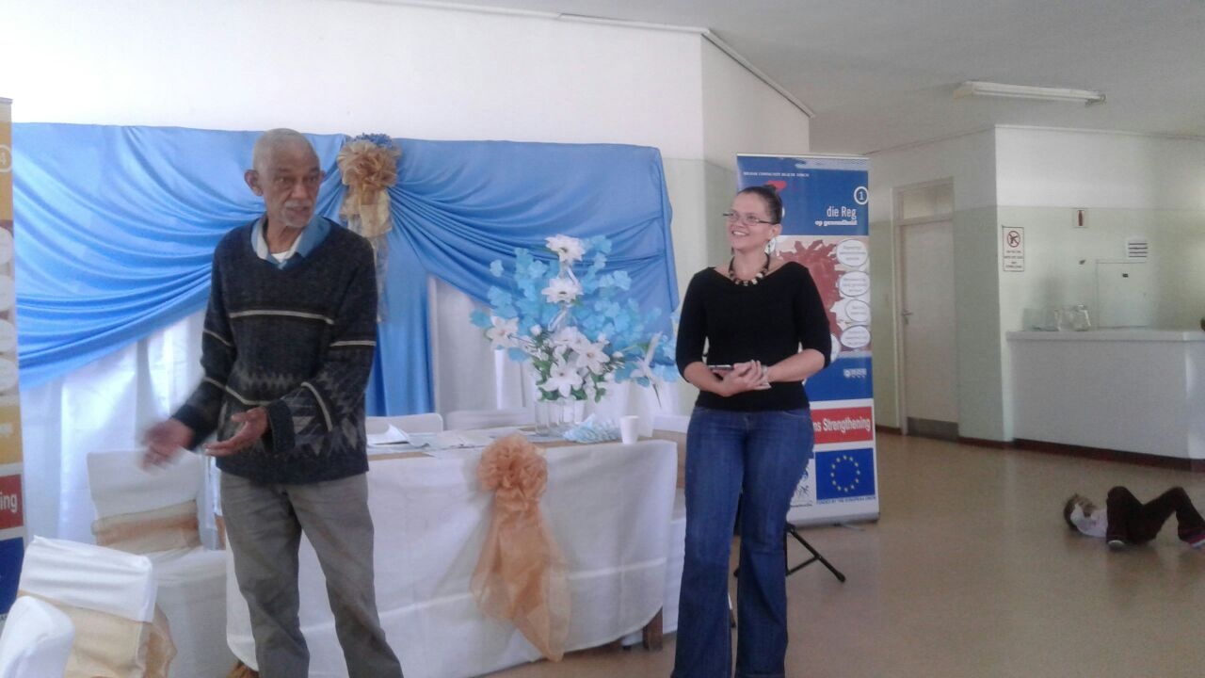
Figure 7: Mr Kenneth Kelley, Chairman, Belhar Community Health Forum and Sister Mary Gell, newly appointed Facility Manager in Belhar

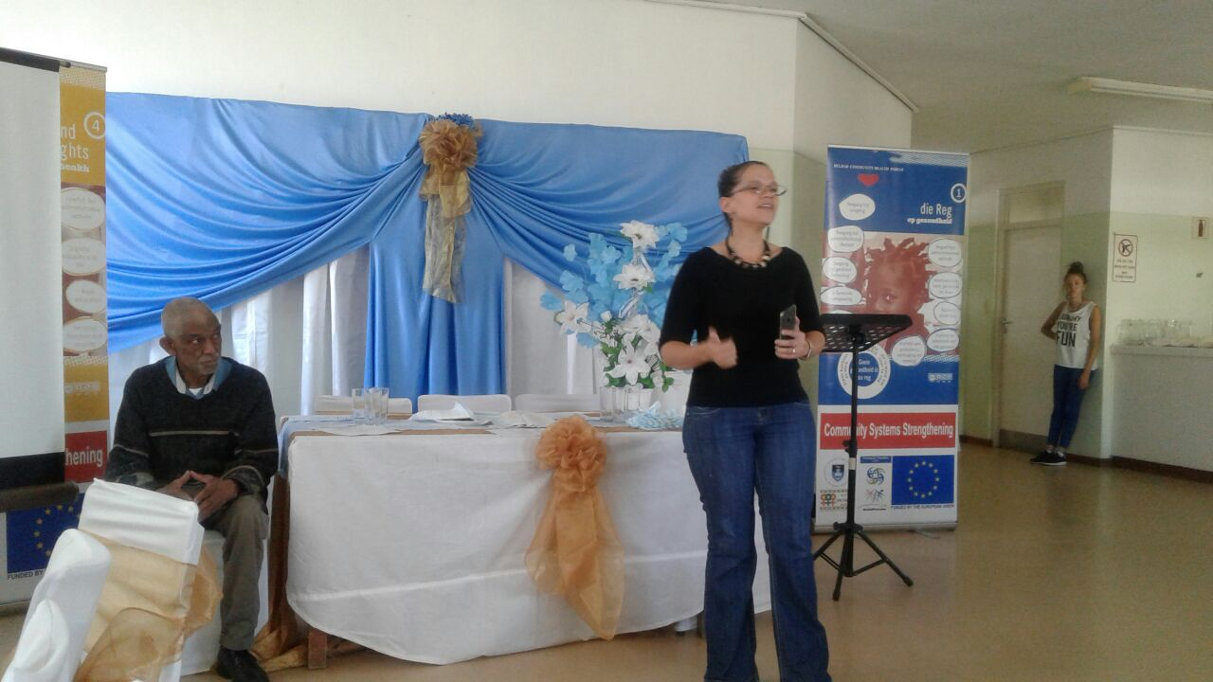
Figure 8: Sister Mary Gell, newly appointed Facility Manager in Belhar

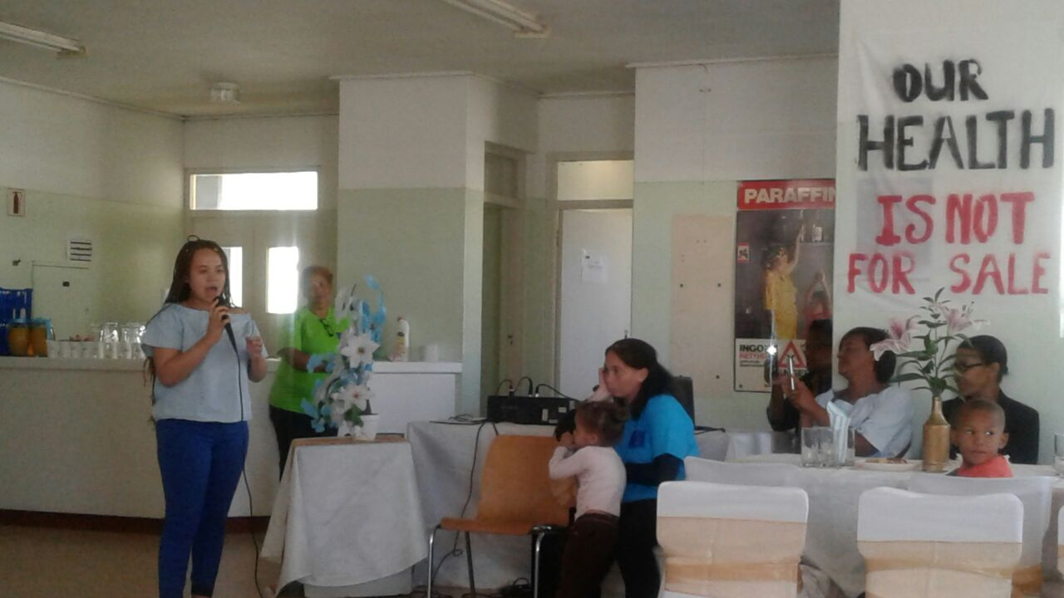
Figure 9: Young talent from Belhar singing a rendition of Halleluja. (Sorry, did not get her name.)

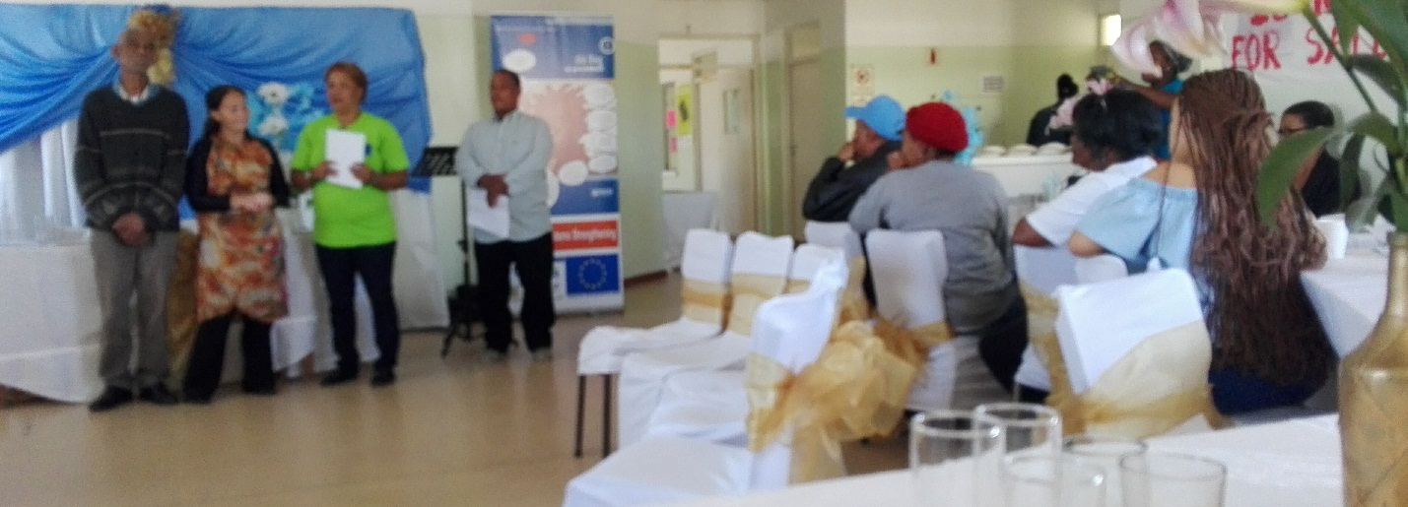
Figure 10: Belhar Health committee support group.

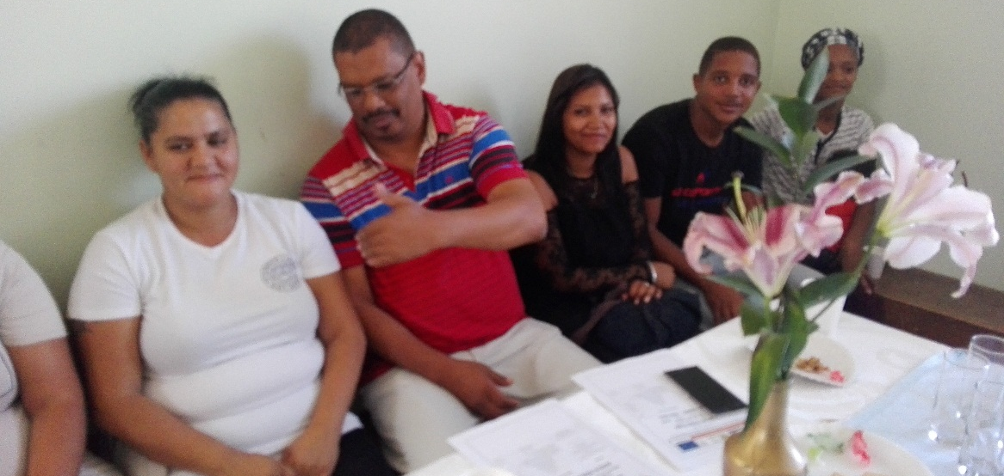
Figure 11: Peace Building trainees supporting the event and Ward Councillor

