Figure 1
Caption: Klapmuts CSS Health trainees, ready to host a dialogue with the Klapmust clinic.
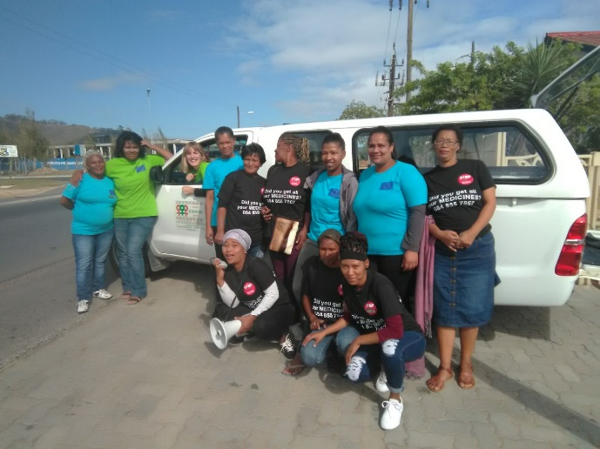
Figure 2
Caption: Mobilising with the loadhailer for the dialogue with the clinic.
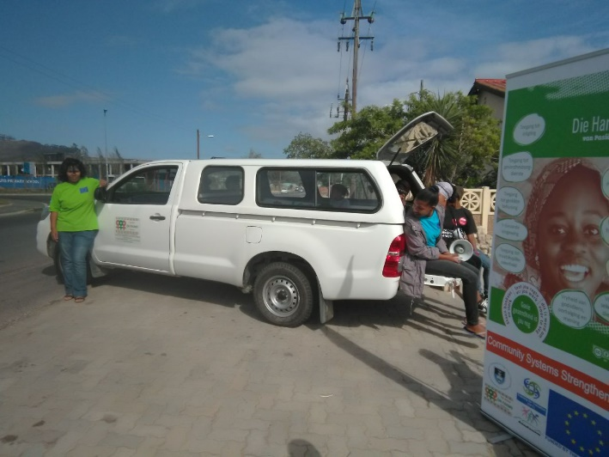
Figure 3
Caption: Part of the group of community members who participated in the dialogue
