Report on the Public Hearing for Community Engagement
Worcester, 12 March 2018
Compiled by Damaris Kiewiets, Chairperson, Cape Metro Health Forum

On the 12th March we were health committees from five different Sub Districts to attend the MEC for health’s position on the current appointment of health committees. The program were supposed to be a day long program and was shorten to only half a day.

The head of office in the ministry did a presentation on the purpose of the day. Dr Beth Engelbrecht did an overview of the projected expenditure for the department’s new financial year 2018-2019. The MEC spoke on the legislation and how it will happen.
The health committees in the room indicated there dissatisfaction with the process and how it will influence the current state of affairs. The application form for this very process was inadequate and pointed out to the MEC by the District Six health committee.

The resolution for the meeting was that the submission date will be postpones until the 15th may 2018. The Members to parliament encouraged the current health to please not boycott the process. We have also asked for an engagement with all health committees across the province.
Figure 1
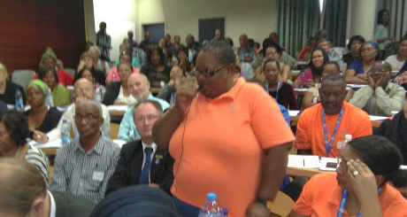
Sis Nowhi representing Gugulethu HC in the Cape Metro Health Forum (CMHF)

Figure 2
Honourable Prof Nomafrench Mbobo speaking to the group
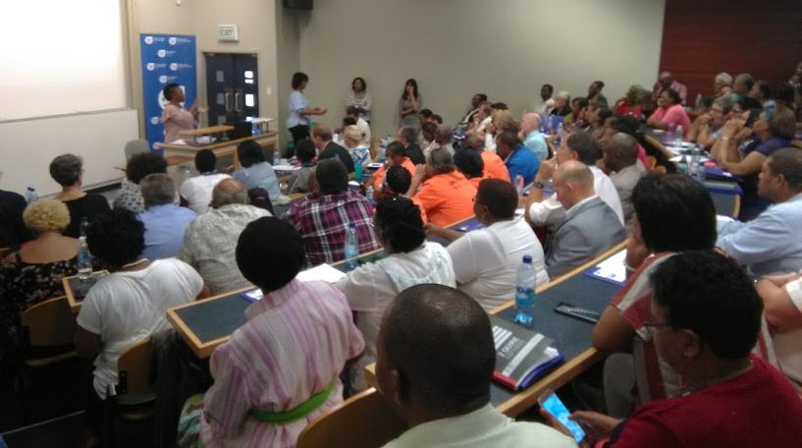

Figure 3
Cape Metro Health Forum well represented with a sea of orange T-shirts
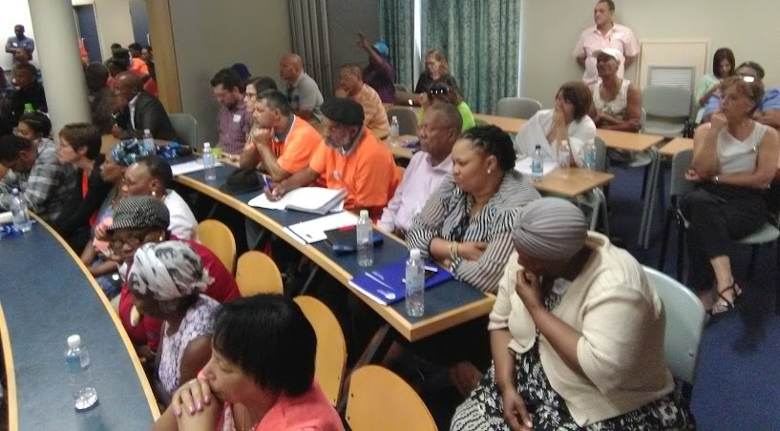

Figure 4
Rebecca form Women on Farms addressing the audience
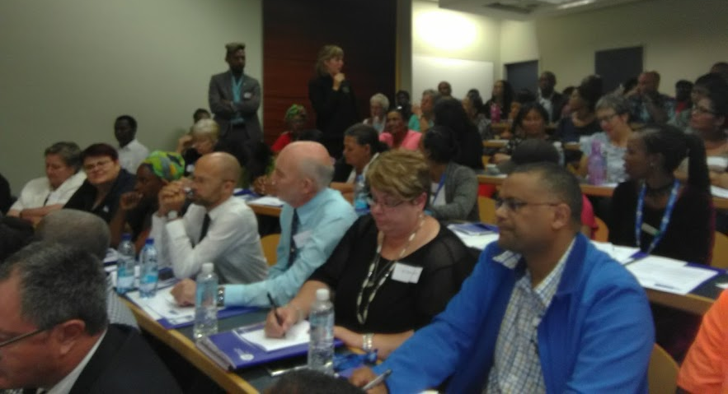
Figure 5
Large number of uninvited Health Committee members
