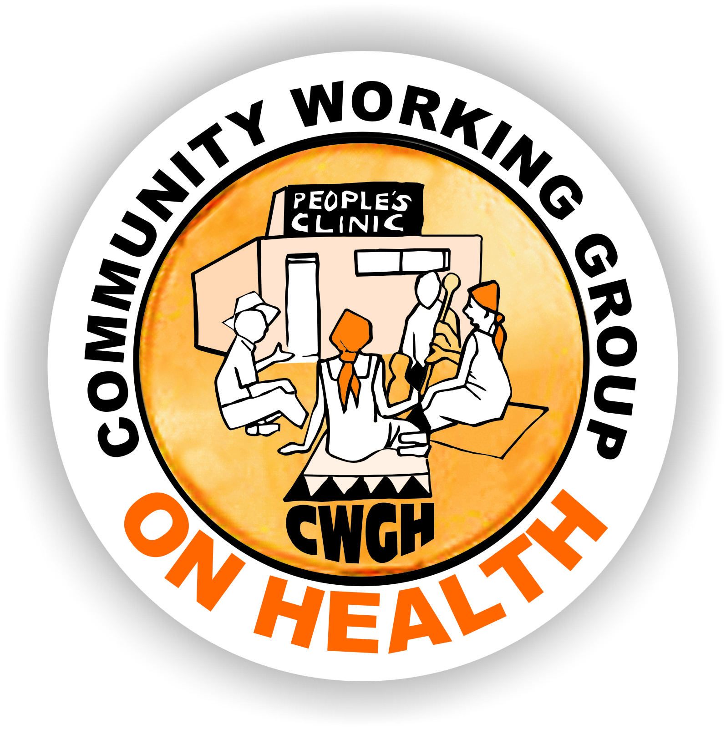 ______
Health Committee Training in East and Southern Africa
Community participation is a key element of the Primary Health Care approach and being recognised as increasingly important for responsive health systems. Structures that allow for community voice and engagement with the health services go by different names in different countries. For example, they may be called Health Committees, Health Centre Committees, Health Facility Committees, Health Management Unit Committees, Health Facility Governing Committees or other terms in different countries.Although they may be formulated in different ways or have different roles, they are all intended to serve some kind of governance function for the health system, enabling communities to participate in the health system.
A number of organisations have been working on how to strengthen these structures across countries of Southern and East Africa over the past few years. You can read more about some of these activities at the URLs below. You may have previously completed a survey as part of this work related to Regional Networking on Health Committees as vehicles for realizing the Right to Health.
The Community Working Group on Health (CWGH) in Zimbabwe is coordinating work in the region to strengthen health committees as vehicles for communities to participate in the health system.The project aims to (i) develop a network of practitioners working with HCCs to document, share and document good practice; (ii) generatean evidence base to advocate for policy and legal recognition of HCCs; (iii) identify gaps and strengthen the capacity of committees through sharing strategies, implementation plans and materials; (iv) exchange information materials and case studies via mailing lists and website resources; (v) raise awareness of work on HCCs in other regions; (vi) build capacity for tracking and monitoring health system budgets and resources; (viii) develop a monitoring framework for effective HCCs.
As part of this project, the Learning Network for Health and Human Rights based at the University of Cape Town is leading a package on sharing training materials. We are seeking to map activities and approaches that provide capacity building for structuring community participation in different countries in the region. This information will be used to create an open repository of resources, information and material that can strengthen health committees in the region. We therefore ask that, if you have information about training and capacity building that is provided in your country or sub-region aimed at strengthening structures set up for community participation, you assist us by completing the template below.We will place these materials and the information on a Website that is publicly accessible so as to share experiences. If you do not wish to have your materials shared, please do not complete the mapping tool. This project is linked to an ongoing study of Regional Networking in which some of you may have previously participated – an information sheet is attached.
If you have any questions, please contact me at leslie.london@uct.ac.za
Thank you in advance for completing this template and please return it to me at leslie.london@uct.ac.zaby August 14th 2015. Feel free to share with any colleagues you think might be in a position to complete this as well.
Leslie London, Health and Human Rights programme, School of Public Health and Family Medicine, University of Cape Town.
The Learning Network for Health and Human Rights: www.salearningnetwork.weebly.com
Community Working Group on Health: http://www.cwgh.co.zw/index.php/en/
Centre for Health, Human Rights and Development: http://www.cehurd.org/

Health Committee Training in East and Southern Africa
Complete this templateonly if there is training provided to Health Committees in your country/province/district. If no training, do NOT complete this.
Your Name:  Barbara Kaim | Your best contact phone number:  +263-772 395 523
Position:  Programme Manager | Your best contact email:  zimbarbs@gmail.com
Organisation:  Training and Research Support Centre | Organisation URL if applicable:  www.tarsc.org
Country:  Zimbabwe | Province or District:  (if applicable)

- Who is the target of the training?  (tick all that apply) |  | - Where does the budget for training come from?  (tick all that apply)
Health Committees* | xx | Government
Health care providers | xx | Donor Funding | xx
Managers in the health system | xx | NGOs
Other (specify) |  | Other (specify)
Please complete the tables below for each target group separately. If the answers are the same for different target groups, then fill in one column but indicate it applies to all target groups.SAME FOR ALL COLUMNS
- Training Materials: | Health Committees* | Health care providers | Health Managers | Other (specify)
3.1 Is there a training manual? (indicate yes or no) | yes
3.2 If available online, please indicate URL | http://www.tarsc.org/publications/documents/HCC%20manual%20FINALAugust%202011.pdf
3.3 Are there other materials? (yes/no) | yes
3.4 If available online, please indicate URL | http://www.equinetafrica.org/sites/default/files/uploads/documents/EQUINET%20HCC%20Diss%20paper%20101%20FINAL.pdf – Equinet discussion paper 2001  http://www.equinetafrica.org/sites/default/files/uploads/documents/EQ%20HCC%20Mtg%20Rep%20FEB2014.pdf : HCC Regional meeting 2014  http://www.tarsc.org/publications/documents/HCC%20Photovoice%20TOT%20mtgRep%202015lfs.pdf – training on the use of Photovoice to strengthen the role of HCCs 2015  Health Literacy training: Loewenson R, Kaim B, Machingura F (TARSC), Rusike I, Chigariro T, Mashingaidze L, Makone A (CWGH) (2007). Health literacy manual for people-centred health systems: Zimbabwe, TARSC, Harare  Also, 4 case study briefs (Zimbabwe, Zambia, Malawi, South Africa) from the region available on the EQUINET website

- Content of Training | Health Committees* | Health care providers | Health Managers | Other (specify)
Does the training address the following issues (please tick those that apply; or make comments as applicable)
health governance | xx
accountability | xx
monitoring | xx
problem solving | xx
fundraising
intersectoral work | xx
Home-based care
committee skills | xx
social determinants of health | xx
political economy of health | xx
The health system in your country | xx
planning cycles in the health service | xx
Budget cycles in the health service | xx
vulnerabilities | xx
conflict management
health and human rights | xx
health literacy | xx
social mobilization | xx

- Format of Training | Health Committees* | Health care providers | Health Managers | Other (specify)
How long does the training take (indicate number of hours or days or weeks) | 5 days using HCC manual
When did this training first start? (month or year) | 2011
Does the training include the following type of follow up:
mentoring | Through CWGH structures for HCC manual; TARSC mentoring at regional level through regional meetings
refresher training | yes
Other ongoing support (specify) | Regional workshops (under EQUINET); health literacy training (see refs above)
Please comment on the sustainability of training  Would you describe the training as mainstreamed (i.e. integrated into the routine functioning of the health system) or is it project-based | The HCC manual was coproduced with CWGH and they have continued to use (and adapt) the manual, mainstreaming it into their district work. CWGH has also incorporated HCC training into their project-based programme on RBM
- Who are the Trainers?
Who delivers the training; | Project Officers at CWGH for HCC manual; TARSC/EQUINET for regional training
What requirements must the trainers have to give the training? | HCC trainers - Health Literacy training, use of participatory approaches, experience working with HCCs and knowledge of HCC roles and functions

- Approach | Health Committees* | Health care providers | Health Managers | Other (specify)
Does the training involve peer training and support? | Yes, through CWGH District structures
Does the training involve a training-of-trainer approach? | TARSC comes in with the regional meetings where trainers at regional level are further trained
What teaching methods are used in the training? (tick as many as apply from the list below)
Seminars
Writing exercises
Participatory Reflection and Action PRA | xx
use of theatre | xx
How does the training draw on participants’ experience, if at all? | Does so extensively. Key to our participatory approach
How does training deal with different languages of participants? | At HCC level – participants work in language they are most comfortable
- Monitoring and Evaluation
How is training documented? | reports
To whom is the training reported?
To funders | yes
to communities | yes
to health departments | yes
Other (please specify)
Are the training reports publicly accessible? (Yes/no) | yes
If the training reports are publicly accessible, plesae give URL | As above
Is the training evaluated? (yes/no) | For HCC Manual – please refer to CWGH
What process is used to evaluate training?

- Reflection

  - What has worked well?
The HCC work has been most successful in districts where HCC members have participated in the Health Literacy programme – either as facilitators or community participants. This indicates that HCCs are more effective in areas where communities have shared information on key health risks and violations of health rights, have developed actions to deal with these risks, and have an improved understanding of how their health systems function.

  - What has been an obstacle / not worked well?
Cutting the 5 day HCC training down to 2 or 3 days in order to meet other programme priorities.

- How does the training fit into broader policy context in the country: (for example, into the Health System / Human Resource capacity building policy, into broader adult education policy in country?
No legal instrument that specifically establishes and sets out the role and functions of HCCs in Zimbabwe. HCCs operate under the policy support set out in the National Health Strategy and guidelines developed by national stakeholders with the MOHCC

- Is a commitment to training HCs reflected in policy? If so, how?
Not directly but the Public Health Act and local government laws broadly provide for public input to health services which, by extension, can include training of HCCs.

Lastly, if you have training materials that are NOT available on line AND you are willing to share these with others in the region through this project, please indicate how we could get copies of the material.
Thank you for completing this mapping tool!

