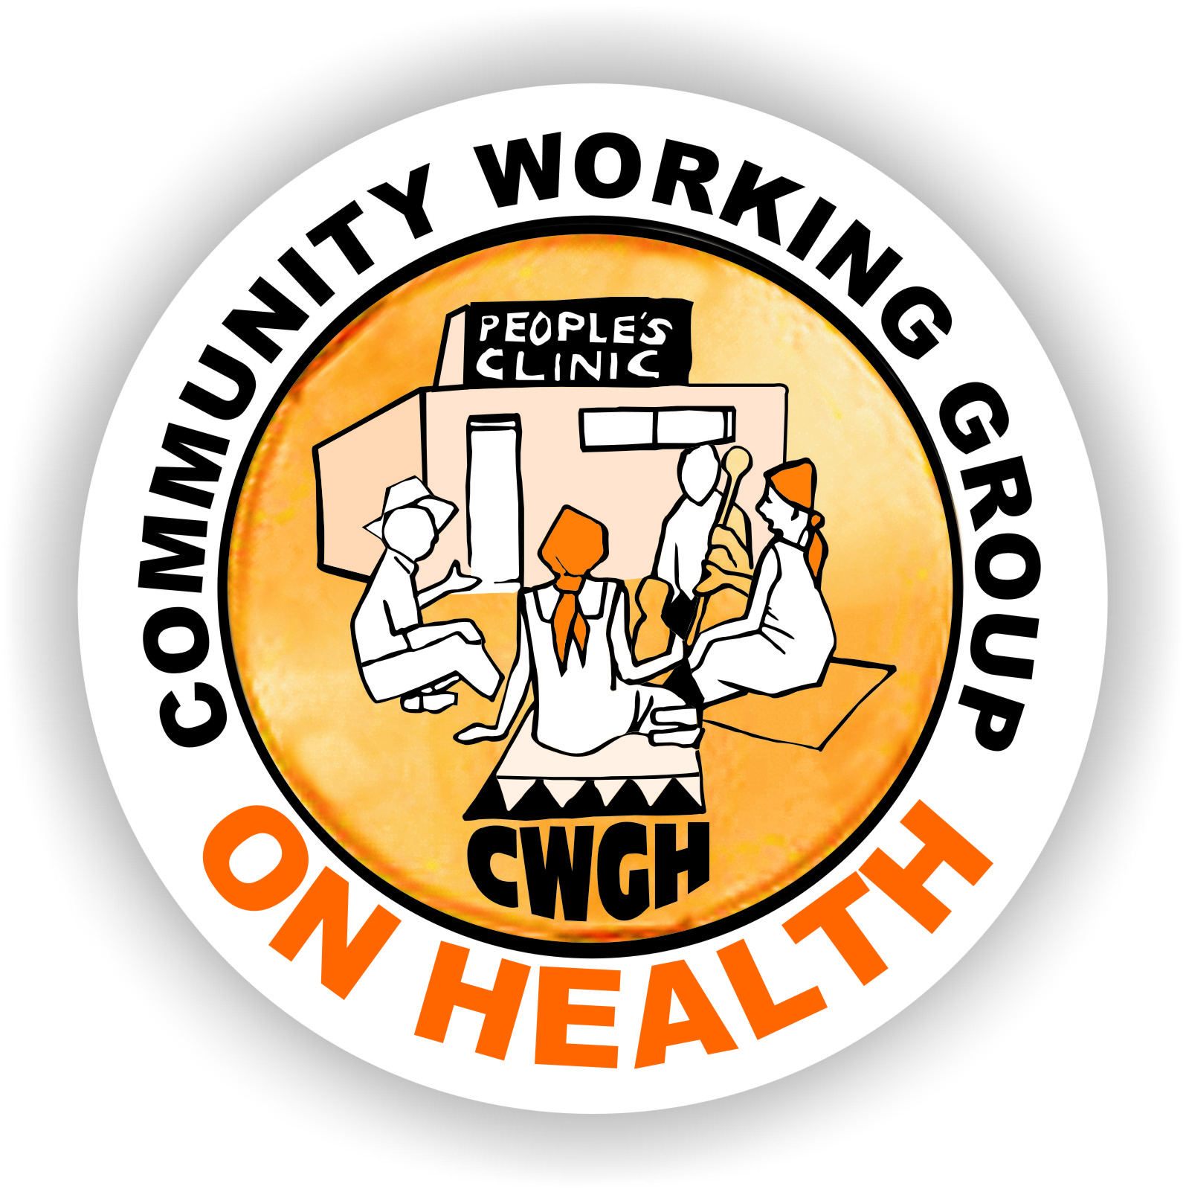 ______
Health Committee Training in East and Southern Africa
Community participation is a key element of the Primary Health Care approach and being recognised as increasingly important for responsive health systems. Structures that allow for community voice and engagement with the health services go by different names in different countries. For example, they may be called Health Committees, Health Centre Committees, Health Facility Committees, Health Management Unit Committees, Health Facility Governing Committees or other terms in different countries.Although they may be formulated in different ways or have different roles, they are all intended to serve some kind of governance function for the health system, enabling communities to participate in the health system.
A number of organisations have been working on how to strengthen these structures across countries of Southern and East Africa over the past few years. You can read more about some of these activities at the URLs below. You may have previously completed a survey as part of this work related to Regional Networking on Health Committees as vehicles for realizing the Right to Health.
The Community Working Group on Health (CWGH) in Zimbabwe is coordinating work in the region to strengthen health committees as vehicles for communities to participate in the health system.The project aims to (i) develop a network of practitioners working with HCCs to document, share and document good practice; (ii) generatean evidence base to advocate for policy and legal recognition of HCCs; (iii) identify gaps and strengthen the capacity of committees through sharing strategies, implementation plans and materials; (iv) exchange information materials and case studies via mailing lists and website resources; (v) raise awareness of work on HCCs in other regions; (vi) build capacity for tracking and monitoring health system budgets and resources; (viii) develop a monitoring framework for effective HCCs.
As part of this project, the Learning Network for Health and Human Rights based at the University of Cape Town is leading a package on sharing training materials. We are seeking to map activities and approaches that provide capacity building for structuring community participation in different countries in the region. This information will be used to create an open repository of resources, information and material that can strengthen health committees in the region. We therefore ask that, if you have information about training and capacity building that is provided in your country or sub-region aimed at strengthening structures set up for community participation, you assist us by completing the template below.We will place these materials and the information on a Website that is publicly accessible so as to share experiences. If you do not wish to have your materials shared, please do not complete the mapping tool. This project is linked to an ongoing study of Regional Networking in which some of you may have previously participated – an information sheet is attached.
If you have any questions, please contact me at leslie.london@uct.ac.za
Thank you in advance for completing this template and please return it to me at leslie.london@uct.ac.zaby August 14th 2015. Feel free to share with any colleagues you think might be in a position to complete this as well.
Leslie London, Health and Human Rights programme, School of Public Health and Family Medicine, University of Cape Town.
The Learning Network for Health and Human Rights: www.salearningnetwork.weebly.com
Community Working Group on Health: http://www.cwgh.co.zw/index.php/en/
Centre for Health, Human Rights and Development: http://www.cehurd.org/

Health Committee Training in East and Southern Africa
Complete this templateonly if there is training provided to Health Committees in your country/province/district. If no training, do NOT complete this.
Your Name: Francis Magaya | Your best contact phone number: +263772588334
Position: Gender Equality Coordinator | Your best contact email:victine13@gmail.com
Organisation: Plan International | Organisation URL if applicable:
Country:Zimbabwe | Province or District: Mutare/Mutasa/Chipinge  (if applicable)

- Who is the target of the training?  (tick all that apply) |  | - Where does the budget for training come from?  (tick all that apply)
Health Committees* | X | Government
Health care providers | X | Donor Funding | X
Managers in the health system | X | NGOs
Other (specify) |  | Other (specify)
Please complete the tables below for each target group separately. If the answers are the same for different target groups, then fill in one column but indicate it applies to all target groups.
- Training Materials: | Health Committees* | Health care providers | Health Managers | Other (specify)
3.1 Is there a training manual? (indicate yes or no) | Yes | Yes | Yes
3.2 If available online, please indicate URL
3.3 Are there other materials? (yes/no) | Yes |  |  | Monitoring tools
3.4 If available online, please indicate URL
- Content of Training | Health Committees* | Health care providers | Health Managers | Other (specify)
Does the training address the following issues (please tick those that apply; or make comments as applicable)
health governance | Yes | Yes | Yes
accountability | Yes | Yes | Yes
monitoring | Yes | Yes | Yes
problem solving | Yes | Yes | Yes
fundraising
intersectoral work
Home-based care
committee skills | Yes | Yes | Yes
social determinants of health | Yes | Yes | Yes
political economy of health
The health system in your country | Yes | Yes | Yes
planning cycles in the health service | Yes | Yes | Yes
Budget cycles in the health service | Yes | Yes | Yes
vulnerabilities | Yes | Yes | Yes
conflict management | Yes | Yes | Yes
health and human rights
health literacy | Yes | Yes | Yes
social mobilization | Yes | Yes | Yes

- Format of Training | Health Committees* | Health care providers | Health Managers | Other (specify)
How long does the training take (indicate number of hours or days or weeks) | Twice a month | Twice a month | Twice a month
When did this training first start? (month or year) | 2012 | 2012 | 2012
Does the training include the following type of follow up:
mentoring | Yes | Yes | Yes
refresher training | Yes | Yes | Yes
Other ongoing support (specify)
Please comment on the sustainability of training  Would you describe the training as mainstreamed (i.e. integrated into the routine functioning of the health system) or is it project-based | Yes | Yes | Yes
- Who are the Trainers?
Who delivers the training; | Plan Staff,Long serving HCC members
What requirements must the trainers have to give the training? | ToT ,and manuals as well as health qualification background,monitoring and evaluation as well as appreciation of gender equality | ToT ,and manuals as well as health qualification background,monitoring and evaluation as well as appreciation of gender equality | ToT ,and manuals as well as health qualification background,monitoring and evaluation as well as appreciation of gender equality

- Approach | Health Committees* | Health care providers | Health Managers | Other (specify)
Does the training involve peer training and support? | Yes
Does the training involve a training-of-trainer approach? | Yes
What teaching methods are used in the training? (tick as many as apply from the list below) | Facilitation, less lectures but interactive learning,peer learning,drama,songs
Seminars | Yes
Writing exercises | Yes
Participatory Reflection and Action PRA | Yes
use of theatre | Yes
How does the training draw on participants’ experience, if at all? | Through theatre participants exploit their own experiences
How does training deal with different languages of participants? | Manuals have been translated into local languages and Facilitaors are competent with local languages. Participants are encouraged to communicate in any language most comfortable to them
- Monitoring and Evaluation
How is training documented? | In trackers,and daily monitoring updates as well as weekly reports.
To whom is the training reported? | To Health Centres,Stakeholders,communities,donors
To funders | Yes
to communities | Yes
to health departments | Yes
Other (please specify) | Government line ministries
Are the training reports publicly accessible? (Yes/no) | Upon request
If the training reports are publicly accessible, plesae give URL
Is the training evaluated? (yes/no) | No
What process is used to evaluate training?

- Reflection

  - What has worked well?
Partipatory learning, Sound feedback mechanisms and monitoring

  - What has been an obstacle / not worked well?

Lack of recognition of HCCs by government
- How does the training fit into broader policy context in the country: (for example, into the Health System / Human Resource capacity building policy, into broader adult education policy in country?

The training is part of the Ministry of Health and Child Care strategy to promote maternal health and child care hence it is already streamlined in the health system sector.

- Is a commitment to training HCs reflected in policy? If so, how?

Not reflected in policy

Lastly, if you have training materials that are NOT available on line AND you are willing to share these with others in the region through this project, please indicate how we could get copies of the material.
Thank you for completing this mapping tool!

