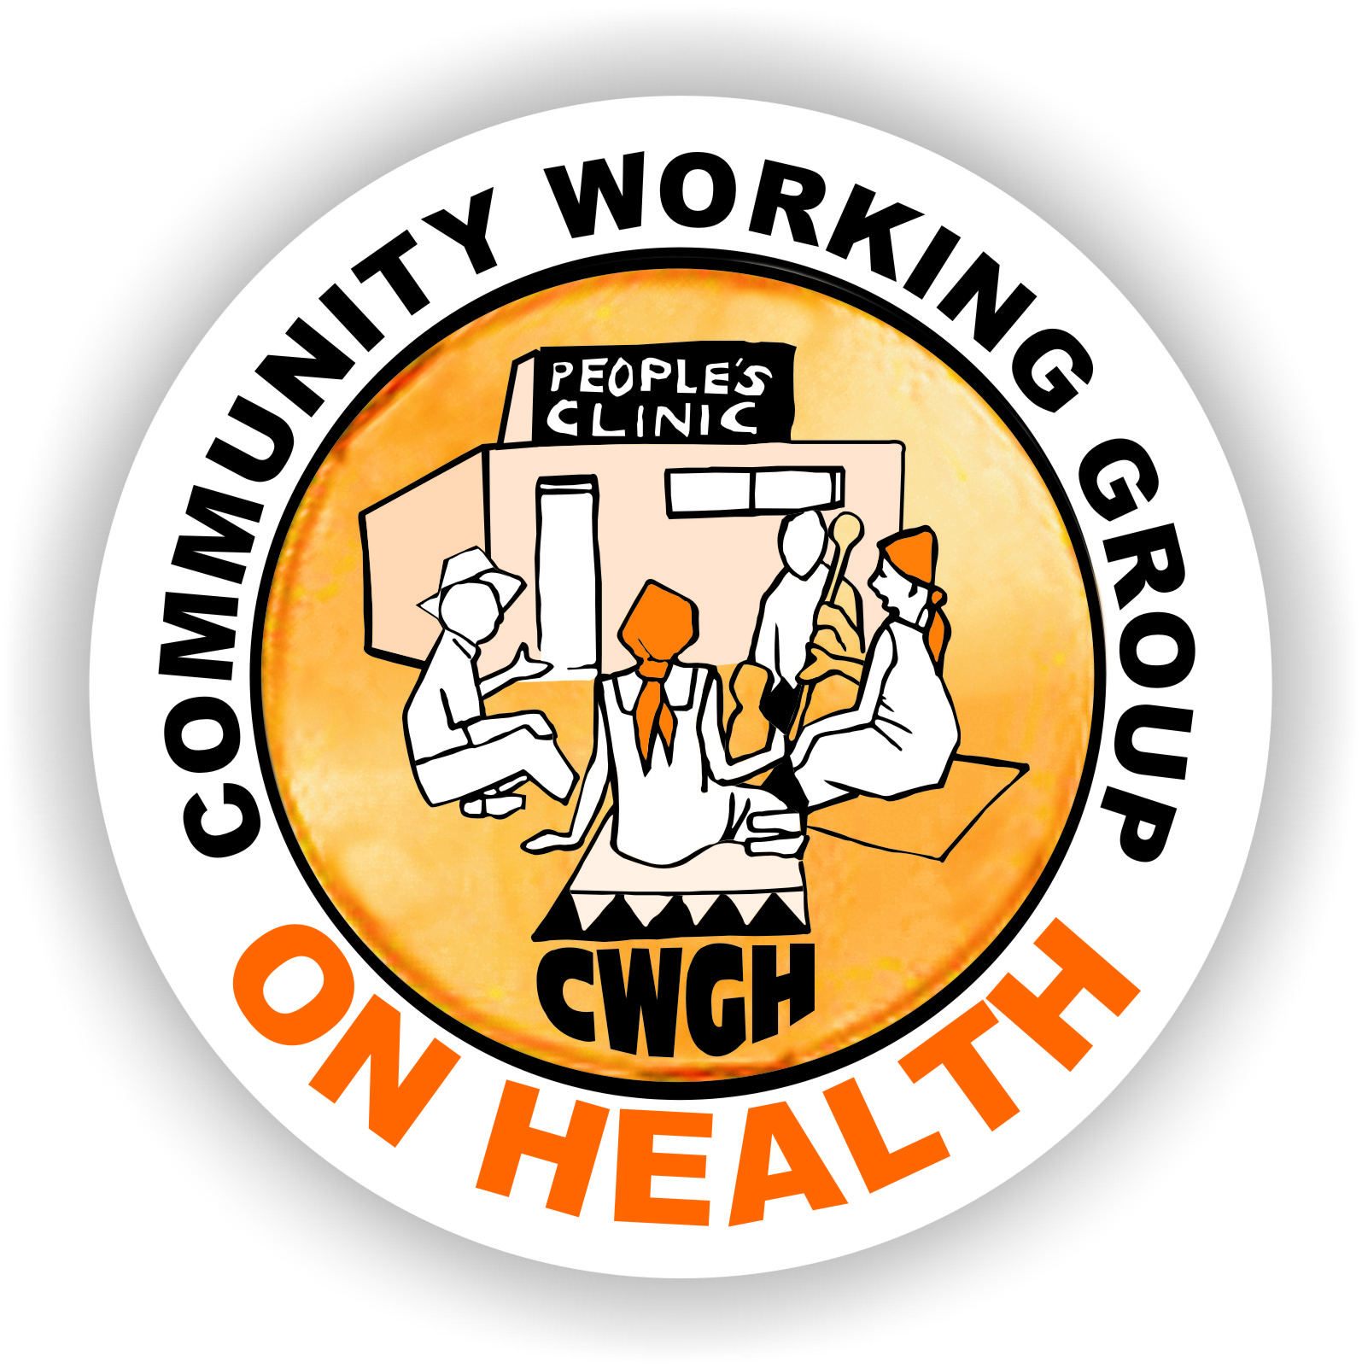 ______
Health Committee Training in East and Southern Africa
Community participation is a key element of the Primary Health Care approach and being recognised as increasingly important for responsive health systems. Structures that allow for community voice and engagement with the health services go by different names in different countries. For example, they may be called Health Committees, Health Centre Committees, Health Facility Committees, Health Management Unit Committees, Health Facility Governing Committees or other terms in different countries.Although they may be formulated in different ways or have different roles, they are all intended to serve some kind of governance function for the health system, enabling communities to participate in the health system.
A number of organisations have been working on how to strengthen these structures across countries of Southern and East Africa over the past few years. You can read more about some of these activities at the URLs below. You may have previously completed a survey as part of this work related to Regional Networking on Health Committees as vehicles for realizing the Right to Health.
The Community Working Group on Health (CWGH) in Zimbabwe is coordinating work in the region to strengthen health committees as vehicles for communities to participate in the health system.The project aims to (i) develop a network of practitioners working with HCCs to document, share and document good practice; (ii) generatean evidence base to advocate for policy and legal recognition of HCCs; (iii) identify gaps and strengthen the capacity of committees through sharing strategies, implementation plans and materials; (iv) exchange information materials and case studies via mailing lists and website resources; (v) raise awareness of work on HCCs in other regions; (vi) build capacity for tracking and monitoring health system budgets and resources; (viii) develop a monitoring framework for effective HCCs.
As part of this project, the Learning Network for Health and Human Rights based at the University of Cape Town is leading a package on sharing training materials. We are seeking to map activities and approaches that provide capacity building for structuring community participation in different countries in the region. This information will be used to create an open repository of resources, information and material that can strengthen health committees in the region. We therefore ask that, if you have information about training and capacity building that is provided in your country or sub-region aimed at strengthening structures set up for community participation, you assist us by completing the template below.We will place these materials and the information on a Website that is publicly accessible so as to share experiences. If you do not wish to have your materials shared, please do not complete the mapping tool. This project is linked to an ongoing study of Regional Networking in which some of you may have previously participated – an information sheet is attached.
If you have any questions, please contact me at leslie.london@uct.ac.za
Thank you in advance for completing this template and please return it to me at leslie.london@uct.ac.zaby August 14th 2015. Feel free to share with any colleagues you think might be in a position to complete this as well.
Leslie London, Health and Human Rights programme, School of Public Health and Family Medicine, University of Cape Town.
The Learning Network for Health and Human Rights: www.salearningnetwork.weebly.com
Community Working Group on Health: http://www.cwgh.co.zw/index.php/en/
Centre for Health, Human Rights and Development: http://www.cehurd.org/

Health Committee Training in East and Southern Africa
Complete this templateonly if there is training provided to Health Committees in your country/province/district. If no training, do NOT complete this.
Your Name:Kassa, Wondwosen Gebeyaw | Your best contact phone number:+251(0)911362824
Position: Health Care Financing Specialist | Your best contact email:kggwonds@gmail.com
Organisation: FMoH/Health Financing and Governance | Organisation URL if applicable:
Country:Ethiopia | Province or District:  (if applicable)

- Who is the target of the training?  (tick all that apply) |  | - Where does the budget for training come from?  (tick all that apply)
Health Committees* |  | Government
Health care providers |  | Donor Funding
Managers in the health system |  | NGOs
Other (specify) |  | Other (specify)
Please complete the tables below for each target group separately. If the answers are the same for different target groups, then fill in one column but indicate it applies to all target groups.
- Training Materials: | Health Committees* | Health care providers | Health Managers | Other (specify)
3.1 Is there a training manual? (indicate yes or no) | Yes | Yes | Yes
3.2 If available online, please indicate URL | No | No | No
3.3 Are there other materials? (yes/no) | Yes | Yes | Yes
3.4 If available online, please indicate URL | No | No | No
- Content of Training | Health Committees* | Health care providers | Health Managers | Other (specify)
Does the training address the following issues (please tick those that apply; or make comments as applicable)
health governance | Yes | Yes | Yes
accountability | Yes | Yes | Yes
monitoring | Yes | Yes | Yes
problem solving | Yes | Yes | Yes
fundraising | Yes | Yes | Yes
intersectoral work | Yes | Yes | Yes
Home-based care
committee skills | Yes | Yes | Yes
social determinants of health
political economy of health
The health system in your country | Yes | Yes | Yes
planning cycles in the health service | Yes | Yes | Yes
Budget cycles in the health service | Yes | Yes | Yes
vulnerabilities
conflict management | Yes | Yes | Yes
health and human rights | Yes | Yes | Yes
health literacy | Yes | Yes | Yes
social mobilization | Yes | Yes | Yes

- Format of Training | Health Committees* | Health care providers | Health Managers | Other (specify)
How long does the training take (indicate number of hours or days or weeks) | 2 days | 2 days | 2 days
When did this training first start? (month or year) | 2008 | 2008 | 2008
Does the training include the following type of follow up:
mentoring | Yes | Yes | Yes
refresher training | Yes | Yes | Yes
Other ongoing support (specify)
Please comment on the sustainability of training  Would you describe the training as mainstreamed (i.e. integrated into the routine functioning of the health system) or is it project-based | It is projected based training; in fact the institutionalization process is going on for creating ownership by the Government. | It is projected based training; in fact the institutionalization process is going on for creating ownership by the Government. | It is projected based training; in fact the institutionalization process is going on for creating ownership by the Government.
- Who are the Trainers?
Who delivers the training; | Our project in collaboration with health minister/bureau | Our project in collaboration with health minister/bureau | Our project in collaboration with health minister/bureau
What requirements must the trainers have to give the training? | Preferable knowledge in Leadership, management, governance and trained on health governance | Preferable knowledge in Leadership, management, governance and trained on health governance | Preferable knowledge in Leadership, management, governance and trained on health governance

- Approach | Health Committees* | Health care providers | Health Managers | Other (specify)
Does the training involve peer training and support? | Yes | Yes | Yes
Does the training involve a training-of-trainer approach? | No | No | No
What teaching methods are used in the training? (tick as many as apply from the list below)
Seminars
Writing exercises
Participatory Reflection and Action PRA
use of theatre
How does the training draw on participants’ experience, if at all? | Community representative and women’s association leader will be trained as per legal framework that allowed to be member of the health governing body or committee | Health facility head and staff representative will be trained as per legal framework that allowed to be member of the health governing body or committee | Local administrator, health and finance bureau heads will be trained as per legal framework that allowed to be member of the health governing body or committee
How does training deal with different languages of participants? | It can be organized in bilingual tons of national language and the local regional languages. | It can be organized in bilingual tons of national language and the local regional languages. | It can be organized in bilingual tons of national language and the local regional languages.
- Monitoring and Evaluation
How is training documented? | Monthly activity report | Monthly activity report | Monthly activity report
To whom is the training reported?
To funders | Yes | Yes | Yes
to communities
to health departments | Yes | Yes | Yes
Other (please specify)
Are the training reports publicly accessible? (Yes/no) | Yes | Yes | Yes
If the training reports are publicly accessible, plesae give URL
Is the training evaluated? (yes/no) | Yes | Yes | Yes
What process is used to evaluate training? | Quarterly supportive supervision is taken place and the changes on health governance after training evaluated | Quarterly supportive supervision is taken place and the changes on health governance after training evaluated | Quarterly supportive supervision is taken place and the changes on health governance after training evaluated

- Reflection

  - What has worked well? The health governing body or committee improved the health service quality, accessibility, equity and improved ownership of the health services by the community and stakeholders. As part of fiscal decentralization the governing body or committee improves the resource planning and administration. Transparency insured, client satisfaction improve, etc.

  - What has been an obstacle / not worked well?
The major obstacle on health governing body or committee is as most the member of the committee are politically assigned, there is huge turnover, the decision sometimes taken in favour of the ruling party rather than the assuring the public interest, corruption and conflict of interest etc.

- How does the training fit into broader policy context in the country: (for example, into the Health System / Human Resource capacity building policy, into broader adult education policy in country?
Health leadership and governance arrangements are essential to ensure effective and efficient for health services that contribute to the health and wellbeing of the population served. Health leadersrequire a unique set of skills to both manage their organization and to liaise with external agencies and
the local community. Health leaders must be able to lead their organizations through change,identifying and solving any challenges that arise.
The Federal Government of Ethiopia through the Health Care Financing Strategy has established thelegislative framework for enhanced Healthfacilities autonomy with authority decentralized to health facilities inareas such as strategy, planning and budget development. To achieve this, health facilities should begoverned by a Governing Board that is responsible to appoint the CEO who in turn leads on allhospital operations and functions.

- Is a commitment to training HCs reflected in policy? If so, how?
Yes, when newly constructed health facilities start functioning and /or when new members appointed, the health governing committee will be established and the training will be organized and training material disperssed

Lastly, if you have training materials that are NOT available on line AND you are willing to share these with others in the region through this project, please indicate how we could get copies of the material.
Thank you for completing this mapping tool!

