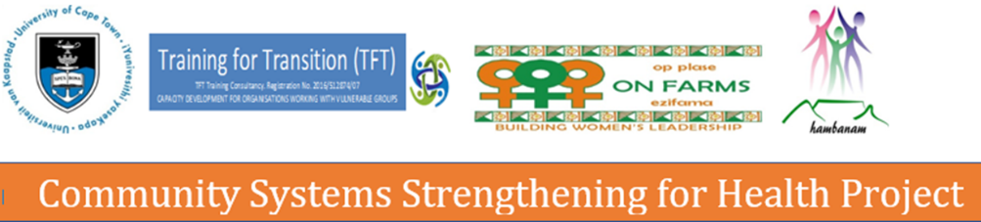****

**Funded by the European Union**

**Report on the National Colloquium on Health Committees in South Africa**

**06-07 OCTOBER 2017**

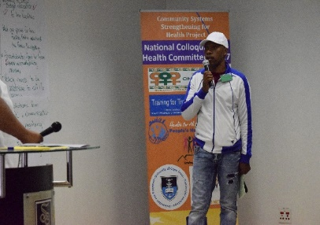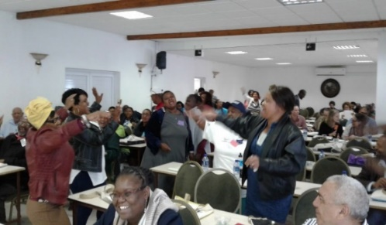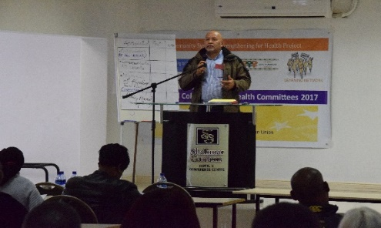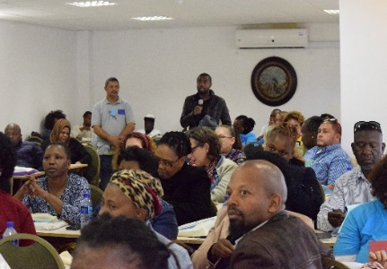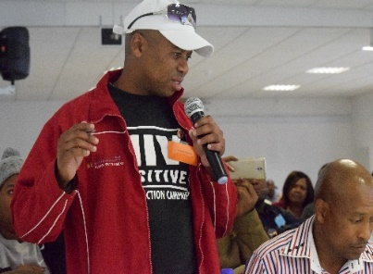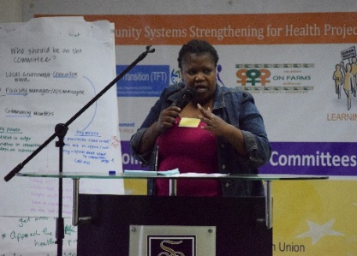

In Collaboration with People’ Health Movement 

Report Prepared by Carron Naidoo – December 2017

Acknowledgements

We would like to acknowledge that images from the national colloquium were provided courtesy of TEKANO – Health Equity in South Africa, @Tekano_SA. We would also like to acknowledge the collaboration of the Learning Network for Health and Human Rights, The Cape Town Metropolitan Health forum, and Peoples Health Movement, the Khayelitsha community health forum and our community systems strengthening project partners, the Belhar community health forum, the Gugulethu community health forum, the Klapmuts clinic monitors, Women on Farms project and Training for Transition.

Funding

This report and meeting was made possible by funding from the European Union (DCI-AFS/2016/374-480), under their socio-economic justice for all grant, channelled through the Department of Justice.

Table of Contents

Acknowledgements 1

Executive summary 3

Introduction 6

Background 7

Day 1: Site visits 9

Day 2: National Colloquium on Health Committees in South Africa 11

Welcome 11

Overview and Introduction 11

Keynote address: National Department of Health (NDoH): Primary Health Care directorate 12

Site visit Presentations 15

Questions and Discussion 18

Response by NDOH 20

Group discussion A: Key issues facing HCs 22

Group discussion B: Context and bringing it all together 29

Action Plan 35

Summary & reflection 39

Election and roles of HC members: an experience from Guatemala 40

Concluding remarks 41

Conclusion and way forward 41

Appendix A: Programme National Colloquium on Health Committees 43

Appendix B: Press Release 47

Appendix C: Attendance Register 50

Appendix D: National Health Committee Interim Task Team list 58

# Executive summary

***Health Committees are a key vehicle for Community Participation – but how can we ensure they are strong mechanisms for meaningful participation by communities?***

Health Committees (HCs) are constitutionally mandated, community-led and drawn organisations which act as a bridge between the facility and the community, and act as a vehicle for community participation in their own health. They are critical structures which exist in the primary health care system to support and strengthen health systems and act as a vehicle for community participation. The National Colloquium on Health Committees (HCs) is a follow-up of a previous Colloquium held in September 2014 and centred around strengthening HCs within the health system. In this Colloquium, we planned to share experiences from our EU-funded project and other projects, draw lessons for best practice from the evidence and discussion and formulate an action plan.

The national colloquium on health committees (HCs) had three major objectives:

1. To create a forum for learning, sharing and strategy development for HCs across South Africa;
2. To support the growth and development of HCs in a re-engineered primary health care system;
3. To review the progress of HCs since the last colloquium in 2014.

To reach these objectives, site visits between 30 HC members from different provinces and 3 healthcare facilities in the Cape Town metropole took place as well as a full day national workshop involving HC members from rural, urban and peri-urban locations across all nine provinces. The meeting also involved about 30 persons from civil society organisations and non-governmental organisations (NGOs), national government, researchers and academics, community based organisations, as well as some representation from provincial government.

The key issues broadly addressed through this meeting were the following:

* The roles of HCs and their criteria for functionality;
* The composition and constitution of HCs;
* What support, training, and resources are needed by HCs;
* Articulation with other governance structures in the health system.

The key action points which came out of this meeting were the following:

* A National HC structure needs to be established which will act as a coordinating forum across the provinces to escalate community concerns above the local level and enable two-way communication;
* The National Health Act (NHA) and all provincial policies on HCs need to be translated into a simplified and accessible format and disseminated to primary health facilities;
* The ideal clinic manual needs to be translated into a concise, simple format and disseminated to primary health facilities;
* An annual colloquium bringing HCs and other key stakeholders together is necessary to ensure collaboration and strategy development;
* HCs need to be provided with support, resources and training to fulfil their roles effectively;
* HC training needs to be standardized across provinces to ensure all HCs have equal access to training and can function better as a national structure;
* There needs to be greater transparency with national, provincial, local government and facility budgets, which should be shared with HCs;
* Local government should help to foster inter-stakeholder collaboration within the community;
* HCs should include ward councillors, community members and facility managers, actively participating on committees to enhance their capacity as a valuable mechanism for accountability;
* Gender equity and vulnerable populations, including sexual and gender minorities, people with disabilities, and the youth need to be represented on HCs;
* A funding model should be developed in collaboration with National, Provincial and Local government and the National HC Structure to support honorariums and resources for committee members and committee activities;
* There needs to be a common framework and language used for HCs, as the term clinic committee is too limiting in terms of the roles of HCs;
* There needs to be a uniform policy on the roles, functions, composition, constitution, language and resourcing of HCs across provinces;
* HCs need to be elected by the communities they serve and should not be appointed by provincial Ministers of Health;
* HC members who were trained should train new HC members using existing material to help fill the training gap and empower their colleagues;

# Introduction

The White Paper on Transformation of the Health System (1997) states that there must be participation in the planning and provision of health services to ensure accountability. Following this, The National Health Act of 2003 sets out the establishment of health committees (HCs) and says that each clinic must have a HC composed of a facility manager, ward councillor, and community members. HCs should involve communities in the planning and provision of local health services, they should act as mechanisms to improve public accountability, promote dialogue, feedback and encourage communities to take greater responsibility for their own health. Section 42 also sets out that provincial legislation must stipulate the role and function of HCs in their provinces and provide for the establishment of these committees. Consequently, each province has developed their own policies and or guidelines on the role and functioning of HCs at different paces. This colloquium, therefore, comes at a critical juncture, where each province currently has their own policy and/or guidelines on HCs and to date, there has been no national forum bringing HC members from all provinces and both urban and rural contexts together. This Colloquium also responds to new policy developments such as the re-engineering of our Health System, the introduction of the National Health Insurance (NHI) and the Ideal Clinic programme.

It was also held at an opportune time in the Western Cape Province, given that the Western Cape Health Facility Boards and Committees Act (No 4, 2016) has recently been enacted. It is hoped that the imminent implementation of the Act will live up to its expectations and support the Provincial Department of Health’s 2030 vision of being both accountable and responsive to the needs of the population.

# Background

The National Colloquium on HCs in South Africa was held under the umbrella of the community systems strengthening project (CSS) as a project activity for strengthening HC’s in the Western Cape. The Colloquium is being funded by the European Union (EU) under its Socio-Economic Justice for All (SEJA) programme. The project is a collaboration between three partners – the University of Cape Town (Health and Human Rights programme in the School of Public Health and Family Medicine), Training for Transition, and Women on Farms Project, working with local communities in three sites. The overall objective of this project is to address the health consequences of socio-economic inequalities in 3 impoverished communities in the Western Cape by creating an enabling environment to support communities’ capacities to undertake advocacy and knowledge dissemination at local, national and regional levels. To strengthen community networks, linkages with local government, partnerships, and coordination of services and strengthen community activities and service delivery, and strengthen organisational and community leadership, working in three sites, Klapmuts, Belhar and Gugulethu, to test models for community systems strengthening, and develop evidence for wider applicability.

The project builds on a previous EU project which focused on building the demand for quality Primary Health Care through strengthening HCs in the Western and Eastern Cape, an EU funding programme which was in partnership with the National Department of Health. This previous work focused on training of HCs and service providers to recognise the roles of community participation in health through HCs. As part of that previous project, which ended in 2015, a National Colloquium on HCs was held to explore how to strengthen HC roles in the health system.

The recommendations from the 2014 colloquium were the following:

Given the long delay in enacting the provisions of section 42 of the National Health Act, we call on provinces to pass legislation as a matter of urgency to recognize the roles and functions of HCs as critically important vehicles for community participation in health.

The recommendations from the 2014 colloquium included the following: The participants called on the Minister of Health to table the status of HCs at the National Health Council to give direction and create an enabling environment for the adoption of provincial legislation on HCs. The participants also demanded that that government should provide the necessary resources (human resource support, training, reimbursement of costs and physical infrastructure as needed) for HCs to function optimally because it is obliged to do so by The National Health Act (NHA). It was also felt that HCs must participate in the development of regulations that is aimed at the functioning of HCs. For example, when the Department of Health, finalize criteria for defining a functional HC as part of evaluating health facility performance in the Ideal Clinic programme and in the work of the Office of Standards Compliance, HCs as well as ward councillors and facility managers must be included in the process. In the same vein the participants would like to see a tiered structure for community participation from facility to national level allowing for two-way communication. Finally, the meeting resolved to pursue the establishment of a National Network on HCs to take forward the resolutions and some of the outstanding work required.

The meeting resolved that the following issues needed attention.

There is uncertainty about the roles and responsibilities of ward councillors in the health committees. The participants would like this to be addressed. The participants would also like to receive guidance on how best to support HCs taking on fundraising roles in ways that supplement but not substitute core government support. The meeting resolved that inter-sectoral interventions are needed to address service provision of health that require cooperation of other government department and political buy-in from elected leaders at local, provincial and national level. The meeting also agreed that as community members they would like to have more understanding of participation as a human rights issue. The participants also expressed a need to have more training on the monitoring and evaluation systems for HCs. They felt the information will help them to know what a functional HC is. The knowledge will also allow them to know when to take legal action to ensure health committees are appropriately recognized and/or when to revert to mass mobilization in alliance with other civil society organisations in health.

Following this, the objectives of this colloquium were to create a forum for learning, sharing and strategy development for HCs across South Africa, to support the growth and development of HCs in a re-engineered primary health care system, and to review progress on HCs since the last colloquium in 2014.

The colloquium was used to workshop the key challenges for HCs, which broadly relate to the roles of HCs and their criteria for functionality; the composition and constitution of HCs (whether they should be elected or not), what support, training, and resources are needed for HCs to function optimally, and how HCs can articulate with other governance structures in the health system to escalate community voice beyond the local level.

The colloquium took place over 2 days, 06th-07th October 2017 and was hosted by the CSS partnership in collaboration with the Cape Metropolitan Health Forum, the Learning Network for Health and Human Rights, and People’s Health Movement. It fostered a wide-reaching grassroots engagement between several stakeholders across a range of sectors and put in place tangible plans of action to advance HCs in South Africa.

# Day 1: Site visits

**Friday 06th October 2017**

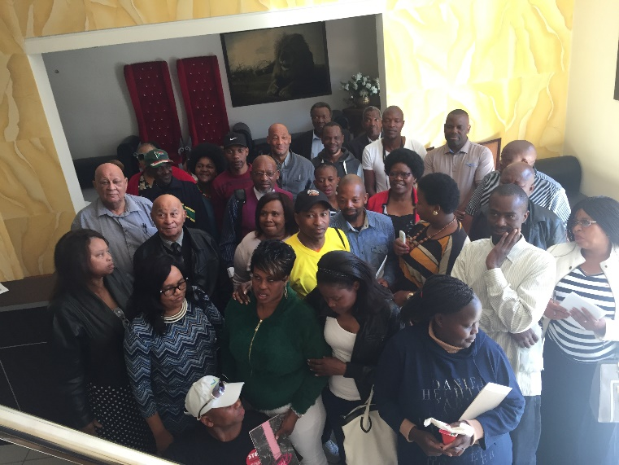

HC members from outside the Western Cape on their way to clinics in Cape Town

Approximately 30 HC members from 8 provinces in South Africa met up with their counterparts at three clinics in the Cape Town metropole, in the Western Cape. The aim of this visit was for health committee members from other provinces to experience the role, functioning, composition, challenges and successes experienced by HCs in the Western Cape, with the goal of reflecting on this experience regarding their own. Three separate groups made up of HCs from each province travelled to St. Vincent’s clinic in Belhar, the Gugulethu Community Health Centre in Gugulethu, and the Site B day hospital in Khayelitsha. They met with the HCs of each facility and visited the facility and in some cases, other nearby facilities, food gardens and community projects, as well as engaging with key population groups, such as the elderly. This was an opportunity to experience the interface between the clinic and the social determinants of health in the wider community and how these social determinants are addressed through the community systems strengthening project in some of these sites.

Groups were given the opportunity to ask questions, give comments, engage with and get feedback from HCs and facility staff. Participants could share experiences and learn from one another. Following this visit, visiting HC members debriefed with each other and reflected on their experiences in a structured format, in preparation for presenting their reflections in the national Colloquium, the following day. Overall, HC members from both urban and rural contexts were engaged, knowledgeable on the ideal clinic manual and policy and enthused at their experiences which are recounted in greater detail in the Site Visit Presentations section of this report.

# Day 2: National Colloquium on Health Committees in South Africa

**Saturday, 07th October 2017**

To address the objectives of the meeting, learning, sharing and strategy development; supporting the growth and development of HCs in a re-engineered primary health care system; and reviewing progress on health committees since the last colloquium in 2014, a meeting was held at Shalimar Gardens Hotel and Conference Centre, Athlone, Cape Town. This meeting consisted of approximately 90 community representatives from all nine provinces and about 30 representatives from civil society, NGOs, researchers and academics, community based organisations, provincial government and national government representatives.

# Welcome

Delegates were welcomed to the colloquium by Ms. Wendy Nefdt, CEO of Epilepsy South Africa and part of the Learning Network for Health and Human Rights. The colloquium consisted of about 120 attendees, notably, HC members from both urban and rural settings across South Africa’s nine provinces. Also in attendance was representation from key civil society groups such as, the Treatment Action Campaign, Mamelani projects, Epilepsy South Africa, Women’s Circle, the Learning Network for Health and Human Rights, Tekano Leadership for Health Equity in South Africa, Women on Farms, Training for Transition, Ikamva Labantu, Health Systems Trust, Peoples Health Movement, Treatment Action Campaign and others.

# Overview and Introduction

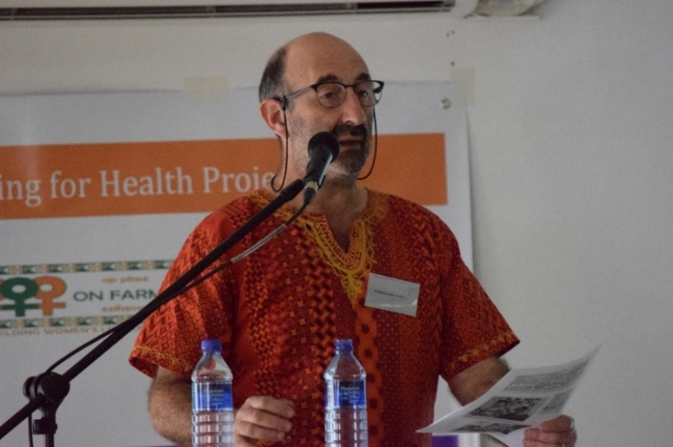

Professor Leslie London, UCT, Learning Network for Health and Human Rights

Professor Leslie London reminded the meeting of the previous colloquium held in 2014 in which there were about 100 participants who discussed the future of HCs. This Colloquium is a follow on, and responds to new policy developments such as the re-engineering of our Health System, the introduction of the National Health Insurance (NHI) and the Ideal Clinic programme, all of which will not succeed if communities do not have a voice. The previous Colloquium was part of a previous EU-funded project concentrating on building the capacity of HCs in the Western and Eastern Cape and identified a gap in the Social Determinants of Health, that lie outside of the health facilities and challenge HCs to broaden their mandate. In this current EU-funded Community Systems Strengthening project, UCT, Training for Transition, Women on Farms Project, the Cape Metropolitan Health Forum, Peoples Health Movement and the Learning Network for Health and Human Rights, are building the capacity of Health Committees to provide leadership and network at a community level to address the social determinants of health in their communities. He also outlined the objectives and format of the meeting and urged the participants to come up with action plans that take this work forward in concrete ways.

# Keynote address: National Department of Health (NDoH): Primary Health Care directorate

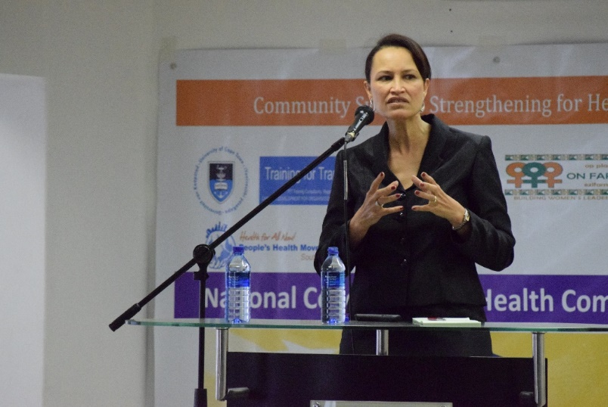

Jeanette Hunter, National Department of Health, Deputy Director, Primary Health Care

Jeanette Hunter, the deputy director general of the primary health care directorate in the National Department of Health delivered a keynote address, centered around the progress of health committees in South Africa. She conveyed that:

* Clinic committees are a key method for providing a structured vehicle for the voices of communities to contribute to improving and maintaining the quality of health services in facilities;
* Through the ideal clinic programme, we have been growing primary health care (PHC) facilities optimally from 0% in 2015, to 9% in 2016 and up to 30% in 2017;
* We need well-functioning clinic committees to ensure that the quality of services in these PHC facilities is maintained and to assist with bringing the remaining 70% of PHC facilities to the desired standard;
* Clinic committees have a mandated function through the National Health Act (2003) and should therefore strive to be catalysts for the health of citizens, due to the occurrences in households, communities and health services;
* There are currently 2095 Clinic and Community Health Centre Committees throughout the country;
* Evidence of the value that health committees add, points to:
* The promotion of accountability and stewardship;
* Positive experiences by members of HCs regarding their contributions and the direct correlation with improved health outcomes;
* High levels of commitment;
* HCs serving as a link between households, communities, civil society, the health sector and politicians;
* Monitoring and feedback between stakeholders;
* Mobilising participation and togetherness;
* Sharing and dissemination of correct information;
* For health governance structures to be successful in their roles, appropriate induction programmes and ongoing capacity building are crucial to support and empower them;
* To facilitate continued functioning of committees, the NDoH have motivated to provinces that committee members should receive an honorarium to cover expenses related to clinic committee activities;
* The NDoH in collaboration with the Health Systems Trust developed a range of documents to assist the capacity building of committee members. These are:
* Facilitation Manual to be used by trainers for the capacity building of both health care staff and members of health governance structures;
* Training Manual which provides all the material required to train relevant stakeholders; and
* Pocket Handbook for ease of reference, especially focusing on the management of health governance structures.
* These documents have been translated into English, IsiZulu, SePedi, SeTswana, IsiXhosa and Afrikaans;
* The functioning of clinic/health centre committees are however challenged by issues which extend beyond the facility into the social determinants of health with problems such as community violence, food insecurity and child abuse, among others;
* The NDoH commend the Community Systems Strengthening project for implementing a new pilot which invests in capacity building at the local level to strengthen community systems, with health committees playing a key leadership role in holding and nurturing activities required to address the social determinants of health.

# Site visit Presentations

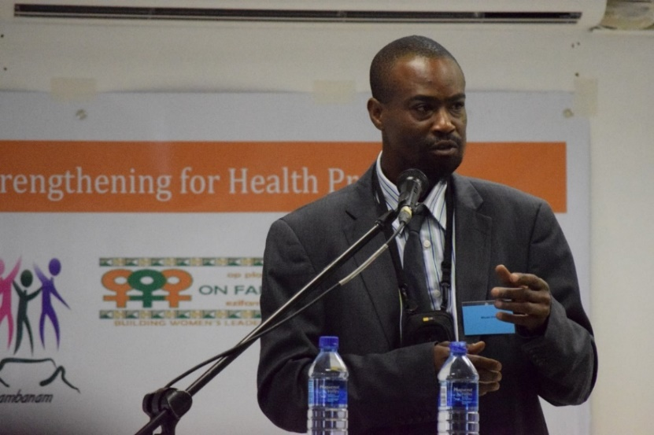

Mfundo Chimarillo, HC member, Nelson Mandela Bay, Eastern Cape

HCs from all other provinces, attended site visits to three clinics in the Western Cape, namely; St. Vincent’s & Chestnut Clinic in Belhar, Gugulethu community health centre in Gugulethu, and Site B day hospital in Khayelitsha. After these visits, a reflection session was held to structure a response to what participants experienced at the clinic and in the community beyond, which is represented below.

**St Vincent’s & Chestnut clinic-Belhar**

Participants identified several challenges after seeing the clinic and interacting with the Belhar Community Health Forum, clinic staff, and community members:

* There was a shortage of staff in the facilities;
* Staff attitudes were negative;
* There was racism and language barriers;
* The HC was not functional due to their growing capacity, a lack of clarity on their roles and reduced linkage to other structures.

There were also some successes and strategies identified:

* A well-functioning booking system is used by the clinic to attend to patients;
* Public meetings to address issues raised by the community;
* Tracing of medication defaulters by health care workers through a red-flag system;
* Engagement with the community and clinic staff through open days;
* The training gap experienced by the HCs was filled by training for transition, and included training on food and nutrition, child protection, health, and chronic disease.
* Existing HC members who were trained can train new HC members.

**Gugulethu Community Health Centre-Gugulethu**

Participants identified several challenges in this clinic and the surrounding community:

* There was a shortage of staff;
* There was a shortage of medication;
* There was a high rate of absenteeism of staff;
* The filing system was poor and did not meet the standards prescribed by the DoH;
* The facility building was not adequate;
* Waiting periods do not meet the time level that are set by the DoH;
* The elderly patients were affected by the long waiting periods;
* The facility was not clean.

Participants also identified some successes and strategies within the clinics:

* Service boards indicating times of operations were visible;
* The suggestion box was visible;
* There is an open day;
* Integration of files to avoid stigmatization of patients receiving medication for chronic illnesses;
* Sub-ward committee members must attend HC meetings for strengthened communication and synergy;
* To avoid long medication queues, the facility should introduce a card system;
* The facility should introduce a community volunteering system to involve people;
* The facility should have an open day, inviting HCs and communities to participate in the operations of the facility;
* To rectify the building issue, HC members and facility staff must make time to do some of the work needed to sort out these issues.

**Site B day hospital-Khayelitsha**

Participants identified several challenges in this clinic and the surrounding community:

* There were no organograms or photos identifying the HC or staff members;
* No support for clinic committees – in terms of stipends;
* Clinic committees have no monthly meetings with the community, but must takeover ward counselor meetings;
* The problem escalation process is not clear.

Participants also identified some successes and strategies within the clinic:

* The clinic infrastructure is large and able to accommodate many people;
* The facility had security;
* The facility was clean, according to the National Core Standard;
* There was medication available to patients;
* The facility had 116 adherence clubs.
* Medication streams were clearly divided for efficiency of medication collection;
* The trauma/emergency department was well staffed;
* Staff had a positive attitude;
* There was staff motivation and encouragement (employee of the month, team building, and others);
* There is a good relationship between the Facility Manager and HC’s.

# Questions and Discussion

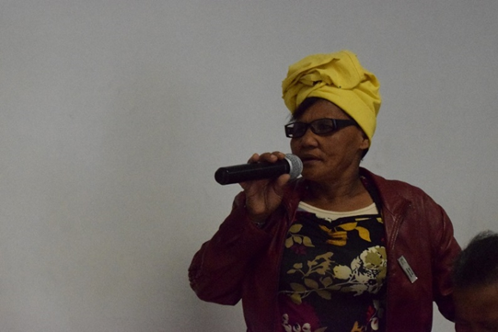

Betty, Hospital Board member, De Doorns, Western Cape.

Several key questions and comments were raised by participants following these sessions and engagements:

* Across provinces, some HC members get a stipend and some do not. Should there not be a common framework?
* Will it be relevant to get a stipend? Will the stipend change anything? The money can accompany an agenda.
* The legislation refers to clinic committees and hospital boards; by calling it HCs are we not expanding the scope?
* How does money flow from the top?
* Can we make a forum that will represent us nationally? From there we can be represented at a provincial level. How are we going to establish this national structure?
* We already have HCs, we already have councilors who have budgets. How do we engage ward councilors? How do we link HCs with local forums? How do we make sure HCs are on ward committees? Moreover, young people and disabled people must be capacitated across HCs nationally. There is a need for structure;
* Why do we not have youth representatives at this colloquium or in HC forums? Youth are looking for learner-ships and things to engage them. What ideas will we come up with for attracting the youth?
* When/ how will HCs get training to properly fulfil their roles as stated in the policies?
* The ideal clinic manual is not accessible;
* Why can’t the National Department of Health NDoH make a uniform policy for all provinces?
* Why did NDoH not contribute any money to HCs?

Some responses and comments were given by the National Department of Health officials, civil society members and UCT:

* The community chest has capacity building classes in the Western Cape which can be accessed;
* We need a co-design plan, involving multiple actors to address the stipend situation and we must work together to prepare a policy position to address stipends;
* The issue of stipends comes back to the constitution, where a clear function has been formulated in national legislation for policies to be translated by provinces. NDoH does not play a role when it comes to stipends;
* In the Western Cape act, clinic committees and hospital boards are combined in one policy but they are not the same. There are politically vested interests at play;
* Health Systems Trust will provide training set up through its provincial offices and they must make sure training is disseminated to the local level;
* Youth unemployment is high. Operation Phakisa is in place to train youth;
* Regarding transportation, the department cars are not there to transport HCs, they are for patients and another mechanism should be developed for getting HCs to meetings;
* The issue of the ideal clinic manual should be dealt with via the facility manager whose role it is to share information and transfer responsibility upwards;
* Also, there is a mobile phone application available for ease of access to manual;
* For community strengthening, disability plays a huge role. Place persons with disabilities into learner-ships to acquire experiential learning.
* The strategy of government is to work with partners like UCT and others and support these partners to work together as a team.
* Good structures will not be built in a day, a lot of work still needs to be done to improve primary health.

# Response by NDOH

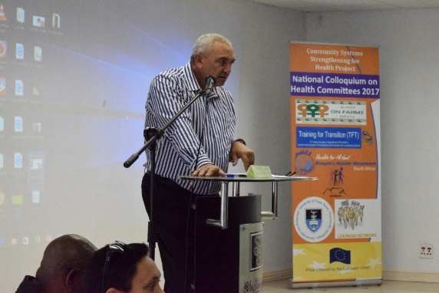

Bennett Asia, National Department of Health

A general response was also given by Bennett Asia, from the National Department of Health, Primary Health Care Deputy Directorate:

* The National Health Act is referred to as ‘framework legislation’. It only provides a framework. Provinces must have its own legislation to address personal issues;
* Section 42 states that provinces must provide in provincial legislation.
* Therefore, a standardised approach to the stipend issue is not entirely possible when considering this;
* Additionally, HC is a voluntary post – and this is where another problem comes in: “How can we expect someone who hasn’t had a meal to pay taxi fare to come to the facility?”;
* We must work together to prepare a policy position to address stipends. This colloquium shows there is a high vibrancy in community participation through HCs and therefore this mechanism is working.
* Regarding the national structure, HCs are based on volunteerism but it is also a requirement in the Health Act.
* In terms of the ideal clinic programme manual, all members attending the colloquium will receive this booklet in hardcopy form.
* At the end of the day it is one country with three spheres of government. HC members’ pledge is essentially: “I am here for the people on the ground”. It would be good, for setting up national structure, for HCs to have a creed, pledge, song, national anthem.
* The CSS programme will set up a mechanism so that proposals may be submitted on thoughts for a national structure;
* The Ideal Clinic Programme Manual will be disseminated in hardcopy to all members attending the colloquium;

# Group discussion A: Key issues facing HCs

The audience were divided into small groups to discuss key issues facing HCs and strategies to combat them, to thereafter provide feedback in the main plenary sessions. These issues focused around, the roles of HCs and what they need to function, the composition of HCs and whether they should be elected or not, issues around support, resources and training of HCs and linkages to other health governance structures. Key themes emerged from the lived experience of HC members and other attendees through their experience and discussion on these issues:

**Group one: Roles and criteria for HCs**

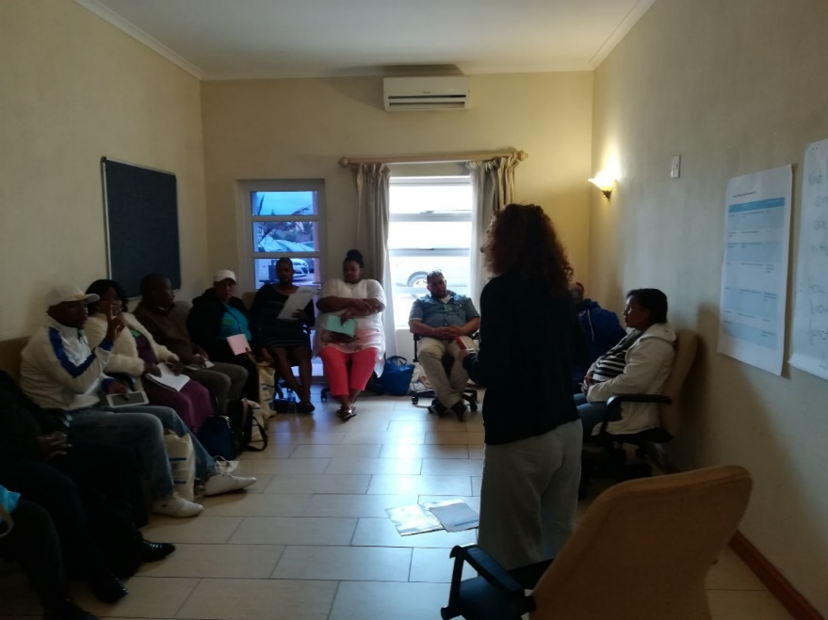

Group one discussions, facilitated by Therese Boulle, UCT consultant.

What are the roles of HCs that are not recognised in provincial policies?

* HCs often act as counsellors;
* They deal with social issues in the facility;
* They locate the current state of health in their community and intervene where necessary;
* Challenges that face the facility extend beyond health;
* Daily contact and checking in with patients;
* Liaison between staff and the community for other issues beyond services;
* Support in spreading resources;
* Creating spaces for engagement;
* Identifying training needs;
* Intervene in strikes;
* Step in when there is a shortage of staff;
* Engage the community in crises situations;
* Leadership;
* Monitoring;
* Piloting policy implementation.

How do we know when a HC is functioning well?

* There is a well constituted structure;
* HC members photos and phone numbers are visible;
* There is feedback from Facility Managers;
* Facility Managers attend HC meetings;
* Roles and functions of HCs are well clarified and they understand the 6 ministerial priorities;
* There is structured feedback to the community.
* There is a record of matters within communities, the actions taken and outcomes;
* Monitoring and evaluation tools are present;
* There is evidence of collaboration with stakeholders;
* Induction and training of new HC’s members;
* There are terms of reference, a constitution, and an agenda;
* There are meeting minutes;
* Annual general meetings and reports;
* Reporting to relevant structures occurs as mandated;
* The presence of reporting tools;
* There are attendance registers and regular meetings;

**Group two: Composition and constitution of a HCs**

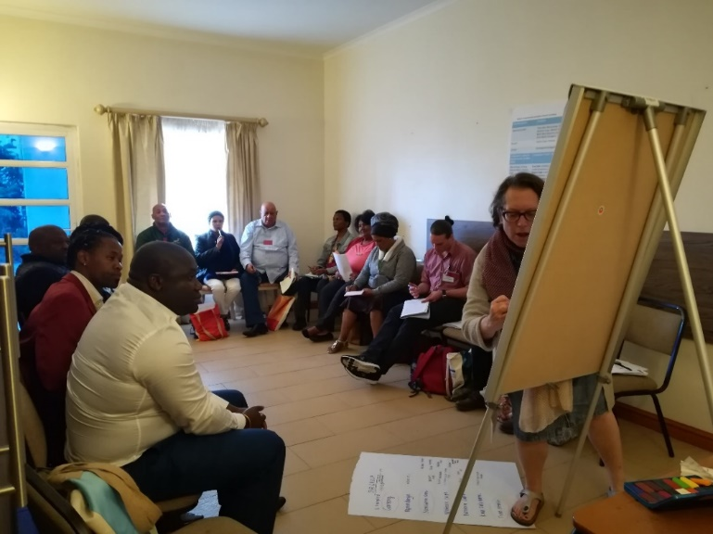

Group two discussions, facilitated by Nikki Schaay, UWC.

Who should be on a HC?

* Ward Councillors
* Facility Managers
* Members of the community, including:
* Religious organisation;
* Sports & recreation;
* Women’s organisations;
* Young women;
* Disability organisations;
* Traditional leaders;
* Traditional healers;
* Youth groups;
* Senior citizens;
* Community policing forums;
* Development forums;
* Gender equity groups;
* labour organisations;
* the Lesbian, gay, bisexual, transgender and intersexed (LGBTI) community;
* Early childhood development centres;
* Community based organisations;
* Non-governmental organisations;
* Home based care organisations;
* School governing bodies;
* Refugee/ immigrant groups;
* Civic associations;
* Social development.
* There is variation in the level of commitment by facility/ operations managers on HCs;
* Community membership should be representative of the community in question;
* Vulnerable groups and gender equity should be considered with this composition.
* Ward committee members should not lead committees but should act as a stakeholder who can communicate with other stakeholders in their capacity as local government;
* In general, the number of people constituting a clinic committee is restricted to 12-15, which means that most sectors of the community are not represented.

How should members get onto a HC?

* Participants agreed that HC members should be elected by the community to which they are accountable;
* Communities have differing needs and the Minister of Health is not always aware of these;
* However, the Minister of Health should not be left out of the process completely;
* In the rural context, HC members should be elected through traditional leaders who liaise with facility members and managers and nominations are then done in relation to the availability of people;
* In the urban context, Ministers of Health are overstepping boundaries in the appointment process as each sub district has a chairperson and they could take a co-design approach;
* The composition of HCs is nuanced and as policies and practices vary across provinces, so should the composition and constitution as per local community structure.

**Group three: Training, support and resources**

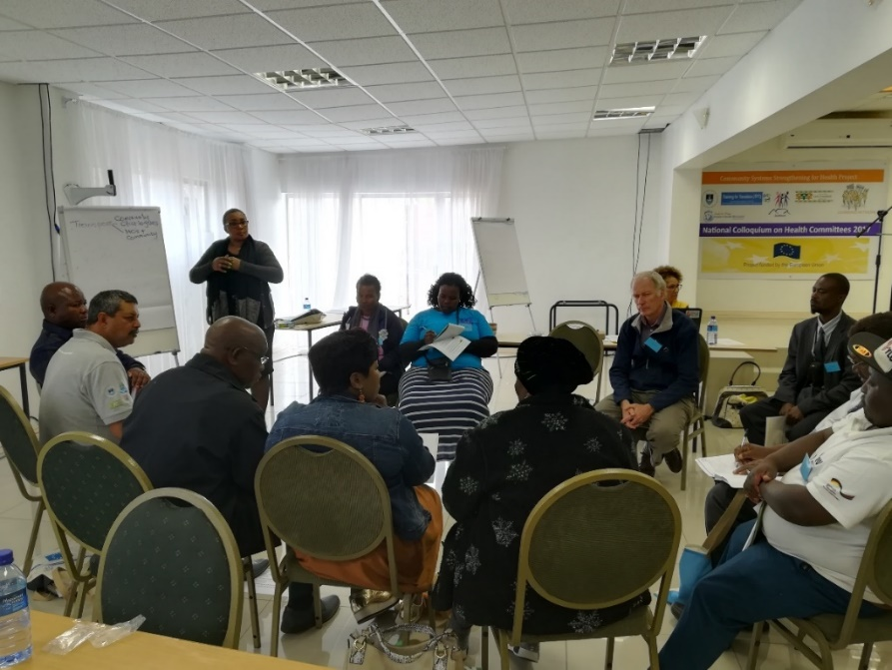

Group three discussions, facilitated by Fundiswa Kibido, UCT

What support and resources are required for a HC to function effectively?

Support:

* Finance for community outreach programmes and campaigns;
* Inter-sectoral collaboration;
* De-briefing sessions and /or counselling sessions;
* Recognition and acknowledgment;
* Awards e.g. monetary, cup of tea, etc;
* Outings for clinic committee members;

Resources:

* Transport for HCs to participate in community engagement activities;
* Use of health facility resources e.g. motor vehicle;
* Airtime allowances;
* Phone allowance;
* Cell phones;
* Computer;
* Fully functional office with internet and stationery;
* Human resources;
* Forms of identification: name tags, t-shirts, uniforms, etc.

What kind of training is needed for a HC to function optimally?

* Induction
* Training on the legislative and policy context
* Skills training:
* Fundraising;
* Reporting;
* Facilitation;
* Ethics;
* Code of conduct;
* Communication;
* Leadership;
* Counselling;
* First-aid;
* Roles and function of a HC;
* Monitoring and evaluation;
* Human resource strategy of the facility;
* Budgeting and finances;

**Group four: Linkages with other Health Governance Structures**

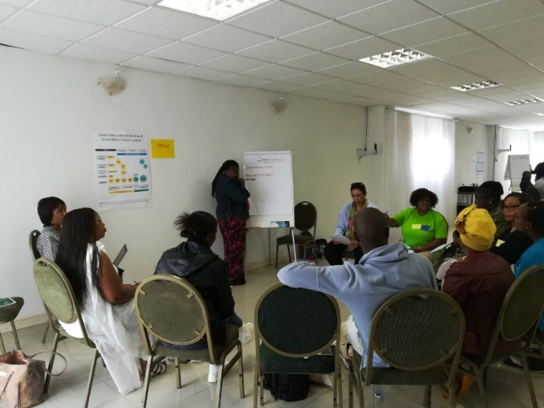

Group four discussions, facilitated by Abegail Schwartz, UCT.

How do HCs ensure that the concerns raised are addressed at higher levels?

* Provincial, district and clinic level budgets are shared;
* Working together with facility managers;
* Working together with ward councillors in districts and sharing information;
* Fiscal transparency for governing structures must also be ensured and shared at the local and clinic level so people can be held accountable.

How should HCs account and report back to communities?

* Make patients aware of policies being implemented at the facilities;
* Use of the District Health Council as a forum to engage local government and the community;
* Take what patients are saying to the upper structures;
* Community dialogues;
* Open forums;
* Facility open days;

# Group discussion B: Context and bringing it all together

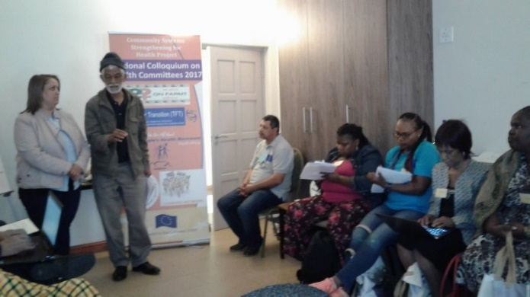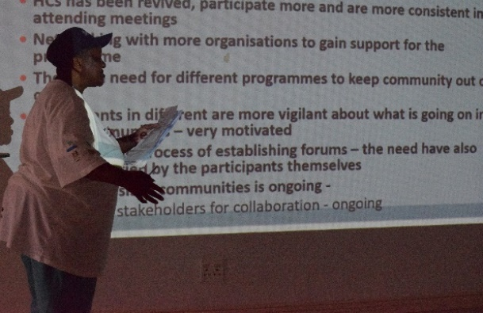

Sheynain Benjamin and Kenneth Kelly, HC members from Belhar Community Health Forum and Gugulethu Health Committee presenting on their committees.

This session started with four separate presentations, run simultaneously from four different health committees. Belhar Health Forum and Gugulethu Health Forum represented their experiences from the CSS project model in their facilities and surrounding communities and two HCs from Nelson Mandela bay in the Eastern Cape presented their experiences as HCs in the Eastern Cape context. These presentations centred around the linkages between the social determinants of health and HCs work, in defining health as extending beyond the clinic. Three case studies are summarised below:

**Case Study 1: St. Vincent’s Clinic, Belhar community health forum, Tygerberg Sub-District, Cape Town, Western Cape**

The Belhar health committee was incepted through the support of the Cape Peninsula University of Technology, the University of the Western Cape, and funded by the Kellogg foundation in the early 1990s. Many jobs were created through this structure to date and they were used as an effective tool to engage the community through annual general meetings and public meetings and dialogues. The facility manager at their clinic has also been involved and present in several community structures. Their present relationship with UCT through the CSS project has brought training and resources to them. They currently have five community projects that they run under the umbrella of the CSS project:

* Home based care;
* Youth programme (community garden);
* Aftercare for children (ECD);
* Income generation projects;
* Assisting the elderly.

Within this project they have received training from Training for Transition on:

* The roles and responsibilities of HCs;
* Gender based violence;
* Chronic disease awareness;
* Child protection;
* Food and nutrition;
* Trauma counselling.

They expressed that as HCs, it is their job to advocate for the healthy lifestyles of their own communities and want this project to be initiated in other provinces. They noted that working with more experienced committees can help launch other committees and facilitate learning and support as it has with them.

They have also encountered some challenges. Since inception of the committee, the relationship with the ward councillor has been difficult and is political. The high turnover of committee meetings is also an issue, as attendance is difficult due to time and costs. It is also difficult to call and organise meetings and to be with the community. They have also never received any payment for their services but prefer to receive an honorarium. Overall, they expressed the difficulty in working without resources. They felt that as HCs they do not need to be confined to facilities as there are issues that they need to deal with in the community outside of facility grounds.

**Case study 2: Laetitia Bam Community Health Centre, KwaNobuhle, Nelson Mandela Bay, Eastern Cape**

Since October 2014, there has been a lack of clarity on the roles of HCs. HCs are looking to improve health, primary health care specifically through community participation. The Eastern Cape Department of Health developed a draft outline of a HC policy in 2010. HCs advocated on behalf of the health department. The department, on the other hand, assisted HCs in training so that they may understand their role. Despite the policy and training, some challenges remain. Some individuals lack interest and some leave due to the lack of a stipend, and though a stipend is mandated in the policy, they have still not received anything. There is a lack of transparency and there is often no accountability in the facility-community relationship, and blame gets shifted, so they often have to fight to get things done. HCs are often ignored when attending facility staff meetings and they meet staff they have not been introduced to previously. They felt that HCs should be on the interview panel when hiring new facility staff. The unavailability of ward councillors is also a major issue as they should form part of the HC but are often unavailable. There should also be a budget to transport HC members to meetings, engagements, community for a, etc as this is an inhibiting factor.

They have also identified some key strategies and learnings:

* Photovoice training is a valuable tool in communicating issues. It has helped in many cases to document certain risks in the community.
* For example, children playing in an open space which is being used as a dumping ground.
* Linkages with other structures in the community is critical.
* For example, creating synergy with SASA, NGOs, NPOs and the Department of Home Affairs is important as people default due to unemployment and hunger.
* Some NGOs plant food gardens to supplement meals. Some NPOs offer meals and train people.
* As HCs, it is important to work interchangeably with these departments.
* The role of ward councillors is also critical, to reach the councillor, their office needs to assist and must work closely with the people.
* Social engagements such as community dialogues are also critical and are places where people can engage.
* In moving forward HCs in the Eastern Cape, there needs to be clarity on certain issues:
* Definition of a stipend;
* Definition of fundraising;
* Provincial policy needs to be interpreted and translated into simplified terms;
* Accountability systems should be put in place.

**Case Study 3: Gugulethu Health Committee, Gugulethu, Cape Town, Western Cape**

The Gugulethu Health Committee was established due to the need to access health information, understand diseases which were occurring in the community, as a response to poor service delivery, related to a medication shortage, turning away sick patients from care, long queues at the facilities, etc which inspired the HC to fight for the rights of patients at health facilities. Some of the founding members of the committee also worked in the community already as home based carers and wanted to be more involved in health-related issues and addressing myths about HIV and AIDS in their community. They collaborated with other local organisations such as home-based care organisations and traditional healers. They undertake activities, such as:

* Health literacy on healthy living
* Identifying community based interventions
* Literacy on health rights to marginalized populations
* Health education and debunking myths around HIV & AIDS
* Patient tracking of those defaulting from medication.

They have collaborated with other organisations such as the Cape Metro Health Forum and learned strategies on how to deal with poor service delivery and other issues in the facility through dialogues with other HCs in Cape Town. When the committee initially started, they functioned through passion and a commitment to their community, but had received no training on their roles or aspects of being a HC member. They received training and capacity building through the Learning Network for Health and Human Rights and UCT on their roles and responsibilities and operated in the policy vacuum in the Western Cape. Following this, they became part of the CSS project as a community site for the pilot. Although the training they received help to build their knowledge and capacitate them, the social determinants of health proved to be a major challenge in their work in the community. Follow up training was recommended to address these issues in greater detail which was fulfilled through the project. They received training on:

* Child protection
* Health promotion
* Peace building
* Access to food and nutrition
* Early Childhood Development

The current challenges in the community centred around:

* Child abuse, neglect and death;
* Domestic violence;
* Abuse of the elderly;
* Killing of women by their partners;
* Poverty and unemployment;
* Orphans of HIV and AIDS – e.g.: 8-year-old children attending ARV clinics on their own;
* Alcohol and drug abuse from a lack of youth role models and other issues;
* Doctors resigning through crime at the clinics;
* Crime and violent incidents resulting in the death of staff members;
* Continued burglaries at the health facilities;
* Lack of adherence to chronic treatment due to hunger and poverty, defaulting to access social grants and smoking of medication.

As a response to these community issues, the HC has collaborated with other stakeholders and:

* Participated in a march against the killing of a health professional and collaborated with other stakeholders;
* participated in a march against child and women abuse;
* The HC was invited by the MEC to provincial parliament to listen to debates on how the province is addressing crime at health facilities;
* For example, a satellite police station outside of the Gugulethu day hospital;
* Involved in 16 days of activism campaign;
* Ongoing communication with MEC for health on building of new hospital to accommodate Gugulethu and surrounding areas.

Following these presentations, groups discussed the CSS pilot model and used all the discussion from the day in engaging with these critical issues to formulate an action plan to advance HCs. This stipulated what needed to be done, who was responsible and attached this to a timeline. Participants felt we needed a National Health Committee Structure, collaboration between committees, clear communication at all levels of government, integration and participation with other stakeholders, policy alignment with HC roles and responsibilities, the allocation of funding for HCs and fundraising activities to move forward as HCs in South Africa.

# Action Plan

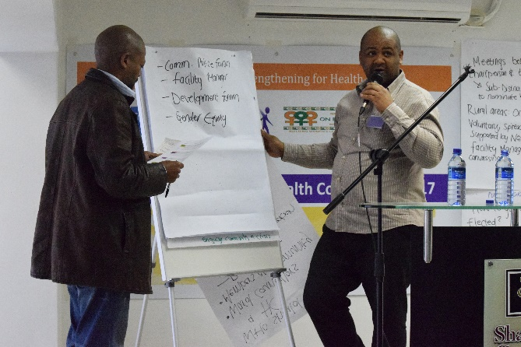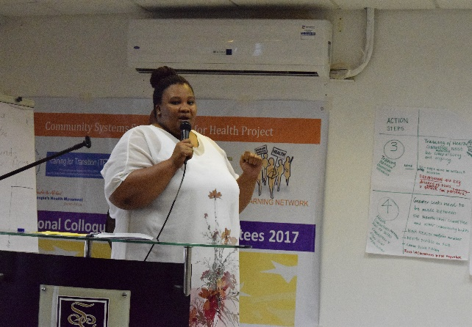

Idriez Rinquest, Cape Metro Health Forum and Tamara Sam, Khayelitsha Health Forum.

|  |  |  |
| --- | --- | --- |
| Action Plan |  |  |
| Activity | **Who** | **When** |
| Set up a national network for HCs:  -mandate, mobilise and organize HCs | Elect at least one HC member from each province | 07th October |
| Have a mandate for the network | National HC network | 07th October |
| Train the trainer:  -role and functions of HC, budgets, ideal clinic manual | Existing HC members who have been trained, non-government partners | Ongoing |
| Hold NDoH accountable | National HC network | Ongoing |
| Hold provincial government accountable | National HC network | Ongoing |
| Share budget on ideal clinic | National Department of Health | ASAP |
| Hold an annual colloquium on HCs (include decision makers) | Department of health partners | October 2018 |
| Report back to provincial structures | Provincial HCs who attended colloquium | October 2017 |
| Engage with chief directors for District Health Services | National Government | ASAP |
| Simplify materials:  -Ideal clinic manual  -Provincial policies  -National Health Insurance  -Budgets/money flow structures | National department of health and partners | 2018 |
| Develop a funding model to support the honorariums and resources for committee members & committee activities | National department of health, Provincial departments, local government and HC’s | 2018 |
| Collaboration between communities | HC’s, local government | Ongoing |
| Clear communication at all levels | National department of health, Provincial departments, National HC Structure | Ongoing |
| Integration and participation with other stakeholders | HC’s and partners | Ongoing |
| Allocation of funding and fundraising | HCs, provincial government, local government, facility | Ongoing |
| Setting up committees:  Where there are no clinic committees-the facility managers must be involved in setting up a committee | Facility Managers | Ongoing |
| Training:  Training of new and existing HC members (must be compulsory and ongoing | Provincial departments of Health, and partners | Ongoing |
| linkages to ward committee and other local organisations:  - Ward health portfolio members  - Health portfolio on SGB  - Community police forums | HCs and Facility Managers | Ongoing |
| Increase community stakeholders:  -improve collaborations  -Increase visibility  -Community forums | HC’s, Facility and local government | Ongoing |
| Accountability structures | National, provincial and local governments, HCs | Ongoing |
| Policy alignment and translation to promote transparency | National and provincial departments of health | Ongoing |

# Summary & reflection

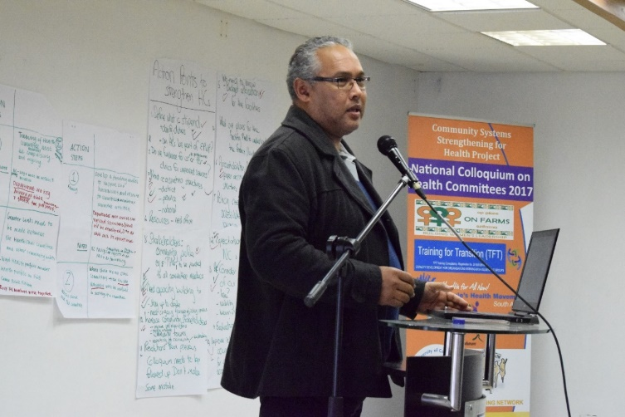

Elroy Paulus, Programme Officer for Advocacy and Communications at Tekano Health Equity

Mr. Elroy Paulus, Programme Officer for Advocacy and Communications at Tekano Health Equity, South Africa, presented a reflection and summary of the day. He noted that the Colloquium remained a space which is not lead by government and has made great efforts to work in partnership with other actors. The Colloquium is an invented space by civil society and not an invited space. However, the national department of health has remained a key partner, though provincial government as well as the city of Cape Town remain significant in their absence at the Colloquium. There is hope that the City of Cape Town and the Western Cape department of Health would be present at the next Colloquium. When you have a centralised structure, it can be corrupted quickly as few have power. Therefore, a decentralised HC mechanism is powerful and the Colloquium is a place where various information on this mechanism is exchanged.

HCs continually provide an active engagement in the health of South Africa. But many challenges remain and we should therefore remain vibrant and challenging. The engagement which this forum has provided and beyond this across provinces, districts, metros, and rural areas is critical and an underestimated strength. We should remain passionate in seeking answers and pose constant questions to interrogate inputs and viewpoints. Once you receive a stipend as a HC member, you are no longer a civil society member. Evidence of the challenges include:

* A deeper understanding is required of the roles, functions and concurrent powers of the different spheres of government;
* For example, what the national, provincial, district, and local government can or cannot do in terms of the current provisions in law;
* We need to establish an understanding of governance structures and how we can get our voice heard;
* The range of experiences are important to know collectively, both to state to government who have committed to listening and continuing to engage with HCs, and for ourselves;
* Continued lack of understanding of the above remains critical, because it is important to know where to lobby within complex health systems;
* The proposal to establish a National Structure is important in communicating with each other inter-provincially;
* It is critical for us to understand how money flows in the health system and the total amount of money for health.

# Election and roles of HC members: an experience from Guatemala

A video submitted by Dr Walter Flores, executive director of the centre for the study of equity and governance in health systems in Guatemala was used as an international case study of the role of HCs in advancing democratic governance in health. The key take home messages from Dr Flores’s submission were:

* The way health committees should be composed is dependent on how health committees are conceptualised in the health system;
* If health committees are conceived as accountable to communities, then they must be elected;
* Legitimacy of health committees is predicated on their election. At the same time, there must be representation of the diversity in communities;
* Health committees can play a very important role in strengthening democratic governance in the health system;
* Health committees should be the vehicle for dialogue between communities and services and involved in decision-making processes;
* This applies to all levels of the health system – local, provincial and national. Where the communication is authentic, there can be great progress in improving services;
* It requires giving away power to elected, legitimate and representative health committees and can in the long-term strengthen democratic governance in the health system.

# Concluding remarks

Professor Leslie London concluded by saying that we need to put our ideas from today together as an agenda for a HC structure, which should have at least one representative from each province. Each province should select their representatives which will form part of a national task team that will set up structures and report back to the colloquium partnership and feed back to the national structure.

# Conclusion and way forward

In accordance with the agreed outcomes of the Colloquium, HC members from each province selected two or more persons to serve on a national task team which will work toward the development of a national network and open a national dialogue and way forward HCs in enacting key action points. This national network must establish a mandate, they also need to mobilise, organize and promote HCs across South Africa by acting as a coordinating forum to liaise with the National Department of Health, advocating for HCs and supporting their oversight functions by raising challenges which are not being resolved at the district level, to ensure community voice reaches beyond the local level.

It was agreed at the meeting that HCs need a national structure and if this does not come to fruition, there will be a national strike. The national task team will have its first meeting as a conference call in December 2017 involving representatives from all provinces who are responsible for reporting back to their own provincial structures and collaboratively moving forward and setting up a national structure.

# Appendix A: Programme National Colloquium on Health Committees

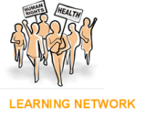 

**A National Colloquium on Health Committees: 07th October 2017**

Date: **07th October 2017**

Time: **09h00-17h00**

Venue: **Shalimar Gardens, Hotel and Conference Centre,**

**424 Klipfontein Road, Surrey Estate, Athlone, 7764, Cape Town**

*Health Committees are a key vehicle for Community Participation – but how can we ensure they are strong mechanisms for meaningful participation by communities?*

Background:

This Colloquium is being held under the auspices of an EU funded project titled “Community Systems Strengthening” within the Public Health and Human Rights programme, within the division of Public Health Medicine, UCT, with Training for Transition and Women on Farms as project partners.

The project builds on a previous EU project which focused on building the demand for Quality Primary Health Care through strengthening Health Committees in the Western and Eastern Cape. This previous work focused on training of health committees and service providers to recognise the roles of community participation in health, through health committees. As part of that previous project, which ended in 2015, a national colloquium on health committees was held to explore how to strengthen health committees’ roles in the health system.

However, during that EU project, we also identified a set of challenges for health committee functioning that were not related to the health services directly but were more in the ambit of the social determinants of health. What should health committees do about problems such as community violence, food insecurity and child abuse – problems that have their roots in social inequalities in and between communities, and which the health services have limited capacity to prevent, but which spend a lot of time and resources in treating the consequences. That led us to propose a new pilot which would invest in capacity building at local level to strengthen community systems, with health committees playing a key leadership role in holding and nurturing these activities. That is how the current project developed, focused on four thematic areas: child safety; food security; peace building; and the prevention and control of chronic diseases.

Within this initiative, we are hosting a follow up national Colloquium which aims:

1. *To create a forum for learning, sharing and strategy development for health committees across South Africa;*
2. *To support the growth and development of health committees in a re-engineered primary health care system;*
3. *To review progress on health committees since the last colloquium in 2014.*

|  |  |  |
| --- | --- | --- |
| PROGRAMME | | |
| Time | Topic | Presenter |
| 08:30-09:00 | ***Registration/ Tea*** | |
| 09:00-09:05 | Welcome | Wendy Nefdt, Epilepsy, SA. |
| 09:05-09:25 | Keynote address: National Department of Health | NDoH Representative |
| 09:25-09:35 | Keynote address: World Health Organisation | WHO representative |
| 09:35-09:50 | Overview and introduction | Professor Leslie London, UCT |
| 09:50-10:20 | Presentation on site visits | Health Committees |
| 10:20-10:30 | Questions and discussion | Plenary |
| 10:30-11:00 | ***Tea*** | |
| 11:00-12:00 | Group Discussions:  1. Roles of HCs and criteria for functionality.  2. Composition and constitution (elected or not) of HCs;  3. Support, resources and training of HCs  4. Articulation of HCs with other health system governance structures. | Break away sessions |
| 12:00-13:00 | Report back and way forward | Plenary |
| 13:00-14:00 | ***Lunch*** | |
| 14:00-14:15 | Video: Election and Roles of Health Committee – experience from Guatemala | Plenary |
| 14:15-15:15 | Presentations by Health Committees & group discussion | Break away sessions |
| 15:15-16:15 | Report back and discussion | Plenary |
| 16:15-16:30 | Summary | Elroy Paulus, Tekano |
| 16:30-16:40 | Closing and thanks | Health Committee Member |
| 16:40 | ***Closing Tea*** | |

# Appendix B: Press Release

 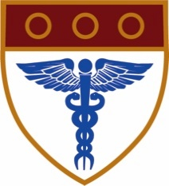

FACULTY OF HEALTH SCIENCES

UNIVERSITY OF CAPE TOWN

COMMUNICATIONS AND MARKETING

Linda Rhoda, Manager

tel. +27 21 406 6685 fax: +27 21 447 8955 or +27 86 612 6390

Faculty of Health Sciences, University of Cape Town, P/Bag X3 Observatory 7935

[linda.rhoda@uct.ac.za](mailto:linda.rhoda@uct.ac.za) www.health.uct.ac.za

PRESS RELEASE ISSUED ON BEHALF OF THE PARTNERS

**National Colloquium on Health Committees to strengthen community voice in South Africa**

**3 October, Cape Town -** 90 community representatives from Health Committees (HCs) across South Africa’s nine provinces will participate in a national colloquium on health committees on Saturday 7th October 2017.

The Colloquium aims to create a forum for learning, sharing and strategy development for health committees across South Africa; support the growth and development of health committees in a re-engineered primary health care system; and review progress on health committees since the last colloquium which was held in September 2014.

“This is an invaluable opportunity to take stock of where we are regarding community participation in South Africa”, says Professor Leslie London, of the Learning Network for Health and Human Rights, Health and Human Rights Programme, School of Public Health and Family Medicine, University of the Cape Town, one of the host organisations.

The programme includes discussions on key issues related to the roles of HCs and their criteria for functionality; the composition and constitution of health committees; issues around support, training, resources; and how HCs articulate with other governance structures in the health system, getting the community voice beyond just the local level.

*“This is to ensure that the health fraternity becomes one of the most respected and that health must be a priority in all aspects,” Mr. Potso Makone, Health Committee member, Swartruggens, North West Province.*

In addition, participants will share experiences from an EU-funded project and other projects, to draw lessons for best practice from the evidence and discussion. A foretaste to this will be site visits planned for Friday 06th October, where health committee members from outside the Western Cape will engage with local health committees at 3 clinics in communities in the Cape Metropolitan area, namely Belhar, Khayelitsha and Gugulethu. This will provide participants with an opportunity to share their unique experiences and witness first-hand how local community members have faced both successes and challenges in their duties in the clinic, but also the interface between the clinic and the social determinants of health in the wider community and how these social determinants are addressed through the community systems strengthening project.

“For me it (the Colloquium) creates a platform to establish a healthy township programme whereby the health of the community is in the hands of its residents and supported by health organisations,” says Mr. Linda Nkuna, Health Committee member from Johannesburg, Gauteng.

The event is hosted by the University of Cape Town’s Health and Human Rights Programme in the Division of Public Health Medicine, in partnership with Women on Farms, Training for Transition, The Learning Network for Health and Human Rights, the Cape Metropolitan Health Forum and the People’s Health Movement.

Approximately 30 persons from civil society groups, NGOs, academics and national and provincial government representatives will also participate. Jeanette Hunter, Deputy Director General, Primary Health Care in the National Department of Health, will deliver a keynote address.

“Hospital boards and clinic and community health centre committees aim to bring this level of public accountability to our health establishments. Health care establishments need to recognize that they no longer act independently of communities and must take account of the environment in which they operate, especially in the rural areas where I come from”, says Ms. Mmabatho Esau, Health committee member, Kuruman, Northern Cape.

Importantly, the Colloquium is also being held at an opportune time in the province, given that the Western Cape Health Facility Boards and Committees Act (No 4, 2016) has recently been enacted. It is hoped that the imminent implementation of the Act will live up to its expectations and support the Provincial Department of Health’s 2030 vision of being both accountable and responsive to the needs of the population.

The Colloquium is being funded by the European Union under its Socio-Economic Justice for All (SEJA) programme, as part of a “community systems strengthening” for health project.

It will be held at Shalimar Gardens Hotel and Conference centre in Athlone, Cape Town on Saturday, from 09h00-17h00.

**For more information about this event, please contact Carron Naidoo on 021 650 5614 or** [**carron.naidoo@uct.ac.za**](mailto:carron.naidoo@uct.ac.za)

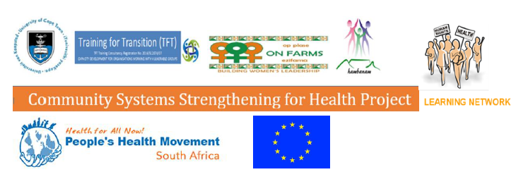

# Appendix C: Attendance Register

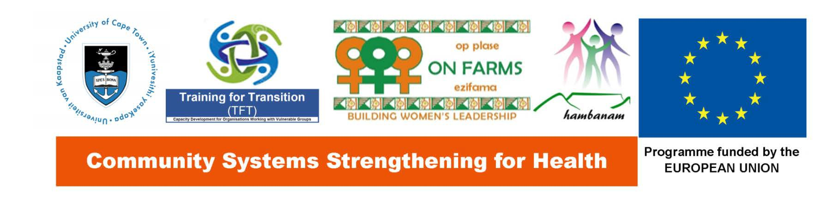

|  |  |  |  |  |
| --- | --- | --- | --- | --- |
|  |  |  |  |  |
| **Name** | **Surname** | **Contact** | **Email** | **Organisation** |
| Professor Leslie | London |  | Leslie.london@uct.ac.za | UCT, PHHR |
| Abegail | Schwartz | 079 447 9234 | abegail.schwartz@uct.ac.za | UCT |
| Fundiswa | Kibido | 082 3343 151 | fundiswa.kibido@uct.ac.za | UCT |
| Carron | Naidoo | 072 2202 849 | carron.naidoo@uct.ac.za | UCT |
| Hanne | Harrichan |  | hanne.haricharan@uct.ac.za | UCT |
| Gafsa | Jonathan | 073 649 9318 | gafsajonathan@gmail.com | UCT |
| Vovo | Baleni | 083 3188 052 | noluvobaleni688@gmai.com | UCT |
| Pius | Mshengu | 076 7610 739 | pius@webmail.co.za | UCT |
| Bennett | Asia |  | Bennett.Asia@health.gov.za | Department of Health W.C |
| Yvonne | Mokgalagadi |  | mokgay@health.gov.za | Department of Health W.C |
| Nikki | Schaay |  | schaay@mweb.co.za | UWC |
| Therese | Boulle |  | tboulle@iafrica.com | UCT |
| Janet | Austin |  | janetaustinsa@gmail.com | UCT |
| Elroy | Paulus |  | elroy@tekano.org.za | Tekano |
| Damaris | Kiewiets | 072 9711 073 | damaris.kiewiets@gmail.com | Cape Metro Health Forum |
| Graham | Lindhorst | 082 532 5099 | graham.lindhorst@gmail.com | Cape Metro Health Forum |
| Estelle | De Beer | 082 086 6002 | no email | Cape Metro Health Forum |
| Dumile | Ndibongo | 071 513 0669 | ndibongo2017@gmail.com | Cape Metro Health Forum |
| Idriez | Rinquest |  | idriez.rinquest@gmail.com | Cape Metro Health Forum |
| Patricia | Ncamile |  | patricia.ncamile@gmail.com | Site Facilitator - University of Cape Town |
| Eric | Galada | 082 697 2955 | vuyilegalada@gmail.com | Health Committee Chairperson for Langa/Bontheuwel health committee |
| Nomvula | Keli | 082 3475 344 | nomvula@ikamva.co.za | Ikamva Labantu, Community Based Worker |
| Wendy | Nefdt |  | wendycw@epilepsy.org.za | Epilepsy SA |
| Mzwandile | Panziso | 079 5887 111 | mzwandilepanziso@gmail.com | NAPWA |
| Sindiswa | Zibaya | 078 6066 981 | Sindiswa.Zibaya@phm.org.za | Peoples Health Movement |
| Nontuthuzelo | Hlafa | 071 7081 169 | nbhlafa@gmail.com | Peoples Health Movement |
| Cleopatra | Sawuti | 084 0480 789 | cleoptra.sawuti@gmail.com | Peoples Health Movement/ Mamelani projects |
| Emily | Basson |  | Emily.Basson@t.org.za | Training for transition |
| Nomvuyo | Mbele | 083 520 3630 | nomvuyo@mamelani.org.za | Health Facilitator, Mamelani Projects |
| Steve | Reid |  | steve.reid@uct.ac.za | Chair of Primary Health Care, University of Cape Town |
| Taurai | Chikotie |  | Taurai.Chikotie@hst.org.za | Health Systems Trust |
| Elise | Levendal |  | Elise.Levendal@hst.org.za | Health Systems Trust |
| Kenneth | Kelly | 084 6938 916 | no email | Belhar Health Committee |
| Athol | De Reuck | 078 889 5597 | athol3122@gmail.com | Belhar Health Committee |
| Sheynain | Benjamin | 084 5735 413 | secretary.tsdhf@gmail.com | Belhar Health Committee |
| Aqeeda | Ras | 073 989 9555 | no email | Belhar Health Committee |
| Zahrah | Donson | - | no email | Belhar Health Committee |
| Sindiswa | Zibaya | 078 6066 981 | Sindiswa.Zibaya@phm.org.za | Peoples Health Movement |
| Nontuthuzelo | Hlafa | 071 7081 169 | nbhlafa@gmail.com | Peoples Health Movement |
| Cleopatra | Sawuti | 084 0480 789 | cleoptra.sawuti@gmail.com | Peoples Health Movement/ Mamelani projects |
| Emily | Basson |  | Emily.Basson@t.org.za | Training for transition |
| Nomvuyo | Mbele | 083 520 3630 | nomvuyo@mamelani.org.za | Health Facilitator, Mamelani Projects |
| Gafieldien | Benjamin |  | No email | Belhar Health Committee |
| Nozibele | Mdayi | 079 6661 672 | nozimdayi@gmail.com | Gugulethu Health Committee |
| Nomthandazo | Simons | 078 378 1943 | No email | Gugulethu Health Committee |
| Joyce | Malebu | 071 105 2807 | No email | Gugulethu Health Committee |
| Akhona | Stofile | 073 739 6758 | No email | Gugulethu Health Committee |
| Nosipho | Peter | 078 475 1689 | No email | Gugulethu Health Committee |
| Pumla | Dyonase | 081 838 2906 | No email | Gugulethu Health Committee |
| Noluvuyo | Gomba | 072 594 2891 | No email | Gugulethu Health Committee |
| Thobeka | Mangcu | 082 849 5081 | No email | Gugulethu Health Committee |
| Sindiswa | Funani | 078 513 3246 | No email | Gugulethu Health Committee |
| Nontimela | Mguzulo | 078 124 1931 | No email | Gugulethu Health Committee |
| Nompendulo | Mpongwane | 060 898 8103 | No email | Gugulethu Health Committee |
| Noluthando | Mazwi | - | No email | Gugulethu Health Committee |
| Daphne | Mashishini | - | No email | Gugulethu Health Committee |
| Rebecca | Mort |  | health@wfp.org.za | Women on Farms Project |
| Diana | Meyer |  | No email | Klapmus Clinic Monitor |
| Alida | Pallas |  | No email | Klapmuts Clinic Monitor |
| Jacoba | Armoed |  | No email | Klapmuts Clinic Monitor |
| Bettie | Fortuin |  | No email | Klapmuts Clinic Monitor |
| Susan | Smith |  | No email | Klapmuts Clinic Monitor |
| Elsabe | Markus |  | No email | Klapmuts Clinic Monitor |
| Mzwandile | Thwesha | 082 640 2657 | mozwa.mt@gmail.com | North West Health Committee |
| Potso Edgar | Mokone | 072 690 8068 | 406ancpco@gmail.com | North West Health Committee |
| Tidimalo | Tlape | 079 769 0321 | no email | North West Health Committee |
| Mohubedu Jeremia | Napo | 073 422 8163 | mohubedunapo@gmail.com | Limpopo Health Committee |
| Ngape | Manasoe | 063 214 3059 | no email | Limpopo Health Committee |
| Hellen Mokgaetsi | Thutse | 061 124 0163 | No email | Limpopo Health Committee |
| Christobel Sindisiwe | Mqadi | 083 790 230 | No email | Kwazulu-Natal Health Committee |
| Gloria Thandi | Muthwa | 083 537 9431 | thandimuthwa@gmail.com | Kwazulu-Natal Health Committee |
| Nonhlanhla Happiness | Zondi | 079 601 2199 | No email | Kwazulu-Natal Health Committee |
| Mmabatho F | Esau | 072 748 6799 | mmabathoesau77@gmail.com | Northern Cape Health Committee |
| Mr. Linda | Nkuna | 062 015 7058 | norccentre24@gmail.com | Gauteng Health Committee |
| Catherine F. | Mokotla | 073 294 2506 | Mokotlafc@yahoo.com | Gauteng Health Committee |
| Falatsi Jerome | Mputhi | 076 914 0554 | No email | Gauteng Health Committee |
| Portia Philisiwe | Nkosi | 083 667 9130 | No email | Mpumalanga Health Committee |
| Nokuthula | Simelane | 071 472 0730 | nokuthulasimelane85@gmail.com | Mpumalanga Health Committee |
| Mduduzi | Nkosi | 060 502 7554 | No email | Mpumalanga Health Committee |
| Nkunzi | Jacob | 076 408 9923 | No email | Free State Health Committee |
| Pakalitha P. | Masilo | 076 151 3232 | No email | Free State Health Committee |
| Sesi E. | Winkel | 072 128 5580 | ellenmaw@gmail.com | Free State Health Committee |
| Billy | Toring | 078 378 1943 / 073 663 3607 | No email | Eastern Cape Health Committee |
| William Thabo | Bense | 078 378 1944 | williambenze@gmail.com | Eastern Cape Health Committee |
| Nolusindiso | Magida | 072 717 4263 / 073 888 2685 | No email | Eastern Cape Health Committee |
| Chris | Jordaan | 827476048 / 082 747 6048 | chrisjordaan1941@gmail.com | Eastern Cape Health Committee |
| Lonwabo | Qana | 071 884 0202 | lqana944@gmail.com | Eastern Cape Health Committee |
| Nceba | Magoxo | 071 051 4019 | ncebamagoxo40@gmail.com | Eastern Cape Health Committee |
| Tembisile | Nogampula | 072 717 4263 | theodorusnogampula@gmail.com | Eastern Cape Health Committee |
| Mfundo | Chimarilo | 076 729 3873 | chimarilom@gmail.com | Eastern Cape Health Committee |
| Phumeza | Luzipo | 078 128 3419 | No email | Eastern Cape Health Committee |
| Xoliswa | Gabuza | - | No email | Khayelitsha Health Forum |
| Khawulezile | Msele | - | No email | Khayelitsha Health Forum |
| Tamara | Sam | 079 968 7017 | No email | Khayelitsha Health Forum |
| Ludwe | Silwana | - | No email | Khayelitsha Health Forum |
| Mzwabantu | Mbuyie | - | No email | Khayelitsha Health Forum |
| Petros | Matho | - | No email | Khayelitsha Health Forum |
| Mzimasi | Mpofu | - | No email | Khayelitsha Health Forum |
| Tembalethu | Nyandeni | 073 926 1856 | ksiyabulela@gmail.com | Khayelitsha Health Forum |
| Vanessa | Dennis | 078 177 4155 | No email | Klipfontein Sub-District |
| Anita | Jefthas | 073 149 1155 | No email | Franschhoek Health Committee |
| Rachel | Pearce | 061 730 7990 | Rachel.Pearce@stellenbosch.gov.za | Franschhoek Health Committee |
| Anele | Madondile | - | No email | Phillippi Health Committee |
| Sabela | Petros | 078 3781 943 / 021 483 9341 | Sabela.Petros@westerncape.org.za sabela.petros@gmail.com | WC Provincial Government |
| Dr. Muthei | Dombo | 072 463 6644 | muthei.dombo@dhsd.limpopo.gov.za | Limpopo Provincial Government |
| Jeanette | Hunter | 012 395 9652 | Jeanette.Hunter@health.gov.za | National Department of Health |
| Mishka | Reddy | - | mishkareddy@gmail.com | Scribe |
| Busisiwe | Kokolo | - | KKLBUS001@myuct.ac.za | Scribe |
| Moneeb | Jappie | - | No email | District Six Health Committee |
| Michael | Clarke | - | No email | District six Health Committee |
| Micky | Allies | - | No email | District six Health Committee |
| Thupane | Makgoba | 072 271 2499 | thupane.makgoba@gmail.com |  |
| Lesifa | Mamasola | 072 809 8793 | Lesifa2010@webmail.co.za |  |
| Aviwe | Ndyokolo | 073 647 4076 | nolyokolo.aviwe@gmail.com | Epilepsy SA |
| Patcick | Mdudula | - | No email |  |

# Appendix D: National Health Committee Interim Task Team list

|  |  |  |  |  |
| --- | --- | --- | --- | --- |
|  | ***Province*** | ***Name*** | ***Contact Number*** | ***Email*** |
| 1 | Northern Cape | Mmabatho Esau | 072 748 6799 | [Mmabathoesau@gmail.com](mailto:Mmabathoesau@gmail.com) |
| 2 | Kwazulu-Natal | Thandi Muthwa | 083 537 9431 | [thandimuthwa@gmail.com](mailto:thandimuthwa@gmail.com) |
| 3 | Kwazulu-Natal | Thabisile Khuboni | 079 484 1973 |  |
| 4 | Free State | Sesi Ellen Winkel | 072 128 5580 |  |
| 5 | Free State | Masilo Petrus Pakalitha | 076 151 3272 |  |
| 6 | Limpopo | Mohubedu Napo | 079 340 8064 | [mohubedunapo@gmail.com](mailto:mohubedunapo@gmail.com) |
| 7 | Limpopo | Hellen Thutse | 076 520 4721 | [MokgaetsiHellen67@gmail.com](mailto:MokgaetsiHellen67@gmail.com) |
| 8 | Mpumalanga | Mduduzi Nkosi | 060 502 7554 | [mduduzi1770@gmail.com](mailto:mduduzi1770@gmail.com) |
| 9 | North West | Mzwandile Thwesha | 082 640 2657 | [muzwaimt@gmail.com](mailto:muzwaimt@gmail.com) |
| 10 | North West | Potso Mokone | 072 690 8086 |  |
| 11 | Gauteng | Linda Nkuna (Mr) | 062 015 7058 |  |
| 12 | Gauteng | Catherine Mokgatle | 073 294 2506 |  |
| 13 | Gauteng | Mputhi Falatsi | 076 914 0243 |  |
| 14 | Eastern Cape | Lonwabo Qana | 071 884 0202 | [lqana944@gmail.com](mailto:lqana944@gmail.com) |
| 15 | Eastern Cape | Thembisile Nogampula | 072 717 4263 | [theodorusnogampula@gmail.com](mailto:theodorusnogampula@gmail.com) |
| 16 | Western Cape | Tamara Sam | 079 968 7017 |  |
| 17 | Western Cape | Sheynain Benjamin | 084 5735 413 | [secretary.tsdhf@gmail.com](mailto:secretary.tsdhf@gmail.com) |
| 18 | Western Cape | Rebecca Mort | 076 372 6202 | [health@wfp.org.za](mailto:health@wfp.org.za) |
| 19 | Western Cape | Eric Galada | 082 697 2955 | [vuyilegalada@gmail.com](mailto:vuyilegalada@gmail.com) |
| 20 | Western Cape | Dumile Ndibongo | 071 513 0669 | [ndibongo2017@gmail.com](mailto:ndibongo2017@gmail.com) |